PROPHET RIVER MOOSE STUDY
December 2002

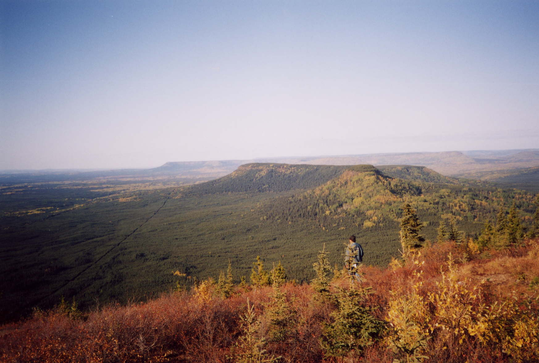

Prepared for:
Bob Purden
Oil and Gas Commission
Fort St. John

Prepared by:
Claudia Houwers
Wildland Resources
Fort St. John

Contracted by:
Brian Wolf
Prophet River Indian Band

1 Summary 4
2 Participants 4
2.1 Session 1 5
2.2 Session 2 5
3 Purpose 5
4 Parasites 5
5 Methods 6
6 Results of Lab Analysis 7
6.1 Cow Moose Submission # 102/03022 7
6.2 Elk Submission # 102/02023 8
6.3 Bull Moose Submission # 102/03806 9
6.4 Young Cow Moose Submission # 102/3806 9
7 General Habitat 11
8 Moose Kill Habitat 12
8.1 Cow Moose 12
8.2 Bull Moose 12
8.3 Young Cow Moose 12
9 Well Sites 13
9.1 Well Sites Visited 13
9.2 Sump Analysis 14
10 Discussion 21
10.1 Objective One 21
10.2 Objective Two 22
11 Recommendations 22
11.1 Determine the Number of Toxic Sites 22
11.2 Determine the Length of Exposure of each Site to Wildlife 23
11.3 Determine the Best Strategy to Deal with Toxic Sites 23
12 Further Studies 23
12.1 Monitor Wildlife 23
12.2 Monitor the Well Sites 24
13 Conclusion 24
14 References 24
15 Appendix: Detailed Analysis 25
15.1 Cow Moose (submission # 102/03022) 25
15.2 Elk (submission # 102/03023) 26
15.3 Bull Moose (submission # 102/03806) 26
15.4 Young Cow Moose ( submission # 102/03806) 27

Summary
This study was initiated as a direct result of the concerns expressed by the local community of Prophet River. Over the past few years, moose that appear ill and sickly have been observed while harvesting moose for food. Symptoms include hair and weight loss, internal and external “lumps” and abnormal body fluids.

Elders have witnessed moose and other animals drinking out of sumps located on well lease sites. Sumps are disposal storage areas for drilling mud additives and the locals are concerned that these compounds, once ingested, will cause illness in the wild game population and through the process of bioaccumulation, could ultimately contaminate people.

The purpose of this project was two-fold, firstly to determine what the “lumps” were. The initial diagnosis (pers.comm. H. Schwantje) were that the skin lumps could be viral papillomas (warts) or fibromas (fibrous lumps) and the internal lumps were tapeworm cysts such as Echinococcus granulosus and/or Taenia krabbei commonly found in natural moose and ungulate populations. If the diagnosis was correct, a secondary purpose was to determine if there is any correlation between the observation of these lesions, any other determinants of moose health (such as poor body condition, poor haircoat and abnormal body fluids) to oil and gas well activity.

The project was initiated in the summer of 2002. Over a period of fifteen days between July and September, three moose were harvested and their carcasses examined. Their internal and external body condition was observed and samples taken and prepared for lab analysis. Tissue samples such as liver, lung and kidney were collected and sent to the Ministry of Agriculture, Food and Fisheries (MAFF), Animal Health Centre in Abbotsford, BC for histopathology tests, while fecal samples were collected and submitted to the Western College of Veterinary Medicine at the University of Saskatchewan for parasitology. The results suggest that none of the moose harvested during this study had abnormal symptoms.

During the hunting session several natural gas well site locations were visited. The purpose of this was to determine if a) sumps, flare pits (areas where natural gas is burned of at ground level) or solid waste piles (e.g. drilling mud waste) were present and b) if these sites were being visited and used by moose and/or other wildlife. Information from the Elders was recorded with respect to the location of previous kill sites where unhealthy moose were found. Evidence of several species was noted at many of the well sites visited. In addition to moose, tracks of deer, caribou, sheep, grizzly bear and black bear tracks were observed with most of the activity centered on either sump, flare pit or contaminated soil.

It is well recognized that drilling waste can be toxic. Nine classifications of mud products are identified as potential toxicants and these mud products are commonly found in sumps (Alberta Energy and Utilities Board, 1996). Therefore, it is in the best interest of the wildlife, that sumps, flare pits or drilling mud solids confirmed to be toxic, be treated and neutralized or a physical barrier be constructed to prohibit access to the wild animals if immediate disposal is not feasible. Future monitoring of wildlife health is essential to determine long term health effects in highly concentrated areas of natural gas activity.
.

Participants
Two separate hunting trips took place between July and September, Session 1 and Session 2. The duration of each session was seven and eight days respectively. Due to unforeseen circumstances the first session was shortened by one day due to a prolonged snowfall storm that took place late July - early August. The weather conditions during the September session were unseasonably warm and sunny and the one day was made up for.

Session 1
Nine hunters made up the hunting party; four elders, four other band members and a biologist. The following people were included in Session 1 (July 27 to August 2, 2002).

Brian Wolf | Project Manager and Band Office Manager
Alec Chipesia | Prophet River Elder
Peter Chipesia | Prophet River Elder
Paul Notseta | Prophet River Elder
Fred Jumbie | Prophet River Elder
Kevin Takoza | Band Member
Duane Takoza | Band Member
Paula Chipesia | Band Member
Claudia Houwers | Consulting Biologist
Table 1: Members of the Hunting Party for the First Session.

Session 2
Ten hunters made up the hunting party; three elders, five band members and one biologist. During the session an exchange of personnel took place. The following people were present during Session 2 (September 22 to September 29, 2002).

Brian Wolf | Project Manager and Band Office Manager
Alec Chipesia | Prophet River Elder
Paul Notseta | Prophet River Elder
Fred Jumbie | Prophet River Elder
Kevin Takoza | Band Member
Kayla Takoza | Band Member (only for first two days)
Kenny Takoza | Band Member
Sandra Noteseta | Band Member
Debbie Hanson | Band Member
Randy Chipesia | Band Member (replaced Kenny after day 5)
Claudia Houwers | Consulting Biologist
Table 2: Members of the Hunting Party for the Second Session

Purpose
The main purpose of this study is to confirm the initial diagnosis of H. Schwantje that lumps occurring on the skin could be viral papillomas (warts) or fibromas (fibrous lumps) while lumps occurring on the internal organs are most likely tapeworm cysts such as Echinoccoccus granulosus and/or Taenia krabbei commonly found in moose populations.

If the diagnosis is correct, a secondary purpose of the study will be to determine if there is a correlation between the occurrence of the cysts and any other determinants of moose health such as poor body condition, poor haircoat and abnormal body fluids to oil and gas well activity.

Based on the outcome, management strategies will be recommended that Industry could incorporate in order to avoid wildlife access to potential health risks and facilitate a safer, healthier environment for wildlife.

Parasites
The parasites that were expected to be found in this study are tapeworms or cestodes. Cestodes occur in many wild and domestic species. In British Columbia, species such as Echinoccocus granulosus and Taenia krabbei are commonly found in canid carnivores (wolves and coyotes) and their intermediate life stages commonly occur in wild ungulate populations including moose.

All tapeworms have a similar life cycle in that they require two hosts – a carnivore and an herbivore. The adult stage of the parasite lives in the intestines of the carnivore, or final host. It looks like a long flat measuring tape which attaches onto the walls of the intestine by way of a ring of hooks and four suckers on its head. This allows the parasite to live in the animal’s gut and absorb nutrients.

The adult stage releases large numbers of eggs in the feces contaminating the ground and vegetation and can cling to the animal’s fur. The contaminated vegetation is eaten by ungulates such as moose. The eggs hatch and the embryos migrate through the blood into tissues where they develop into a larval or immature form of the tapeworm. The larval stage can be one of several types of cysts or fluid filled cavities. A “cystercercus” is a simple fluid filled sac with a single larva. This is typical of Taenia krabbei infection in moose where cysticerci are found in muscle tissue. Another type of tapeworm larvae is the “hydatid” cyst of Echinoccoccus spp. Tapeworms. These are more complex with smaller cysts present within the main cyst wall and are also commonly present in moose tissues but in the liver and lung. Tapeworm cysts stay inactive in the body until the prey is eaten by a predator (wolves, dogs, coyotes, fox or lynx) or they can be neutralized by the body’s immune system. Once in the carnivore the larvae develop into adult forms in the intestine to continue the life cycle.

Humans can only be infected by tapeworm eggs found in the droppings of the final hosts, (wolves, dogs etc.) or by handling their pelts. The cysts in herbivores do not infect people while it is not recommended to eat the infected organs, the meat is safe for consumption. It is important to remember not to feed tissues infected with cysts to dogs as they can serve as an alternate host and can complete the life cycle. (www.nwtwildlife.com).

Methods
The collection of tissue samples is based on a protocol obtained through personal communication with Provincial Wildlife Veterinarian, Dr. Helen Schwantje. There were two main stages involved with the procedure: 1) external tissue assessment and 2) internal tissue assessment.

While collecting tissue samples, visual observations were conducted to determine the condition of the animal at the time of death. Observations were documented by photographs and notes. The entire handling procedure for each animal was video recorded.

External Tissue Assessment
External features and characteristics were documented, particularly the condition of teeth and skin. Photographs were taken showing the condition of the animal featuring any abnormalities, tooth wear, hair loss, ticks, lesions or lumps. Detailed notes were taken as to the condition of the animal noting where abnormalities were found and location of external tissue samples collected.

Internal Tissue Assessment
The internal organs were photographed and detailed notes recorded regarding the condition of each organ. All of the organs were checked for any signs of abnormalities such as lumps (solid) or cysts (fluid filled). The following organs were given particular attention.

Kidneys
A visual inspection of the kidneys involved assessing the amount of perirenal fat which provides evidence of body condition. Following this, any abnormalities of the kidneys was photographed, recorded and removed. Sections no greater than 1cm thick were cut and placed in a 10% neutral buffered Formalin solution.

Liver & Lungs
The liver and lungs were examined as with the kidneys. The number of cysts was counted and representative sections were preserved in Formalin.

Other samples
Samples of feces (pellets) were collected. Approximately 10 pellets were removed from the terminal rectum, placed in bags and frozen immediately.

Results of Lab Analysis
Tissue samples were collected and submitted to the Animal Health Centre, MAFF, in Abbotsford BC, (www.agf.gov.bc.ca/croplive/anhlth/ahc/ahcweb.htm) for histopathology analysis. Submissions to the lab included tissues of liver, lung, kidney as well as and any other abnormal tissues.

Fecal samples were also collected and submitted to the University of Saskatchewan for parasitology. Tests performed included the Baermann Test (test for larvae of nematodes such as muscleworm, brainworm and lungworm) and Wisconsin Test (test for Liver flukes).

Parasite Groups | Common Name
Cestodes | Tapeworms
Nematodes | Roundworms
Tremetodes | Flukes
Table 3: The Three Main Types of Parasite Groups

Three moose and one elk carcass were harvested and assessed for abnormal occurrences. Below are the results of the visual field assessment conducted by the Claudia Houwers and the interpretation of lab results which were provided by Helen Schwantje.

Cow Moose Submission # 102/03022
The cow moose was harvested just off of the 156 road on July 30, 2002. She was a young female moose approximately two years old.

Visual Assessment
The cow moose appeared to be in good condition with no observable external lesions or abnormal body fluids. The liver appeared normal except for five, small white cysts on the surface. These cysts appeared to be clear, fluid filled sacs (0.5 x 0.5 cm) with a small white substance inside. The lungs appeared normal except for four lumps located on the surface; small hard lumps that were barely discolored.

Notes and photographs were taken of the condition of the hide (external) and organs (internal).

Interpretation of Lab Results
The lab results concluded that the five white cysts on the liver were intralesional cestodes and moderate granuloma. This means that the liver has typical tapeworm lesions, which were unidentifiable to species, with accompanying tissue reaction (i.e. granuloma). This is not serious or significant (H. Schwantje).

The lumps on the lung were symptoms of bronchopneumonia. This is essentially a lung infection affecting the airways that had been present for some time. There is no impression of the cause, but it could be bacterial (H. Schwantje).

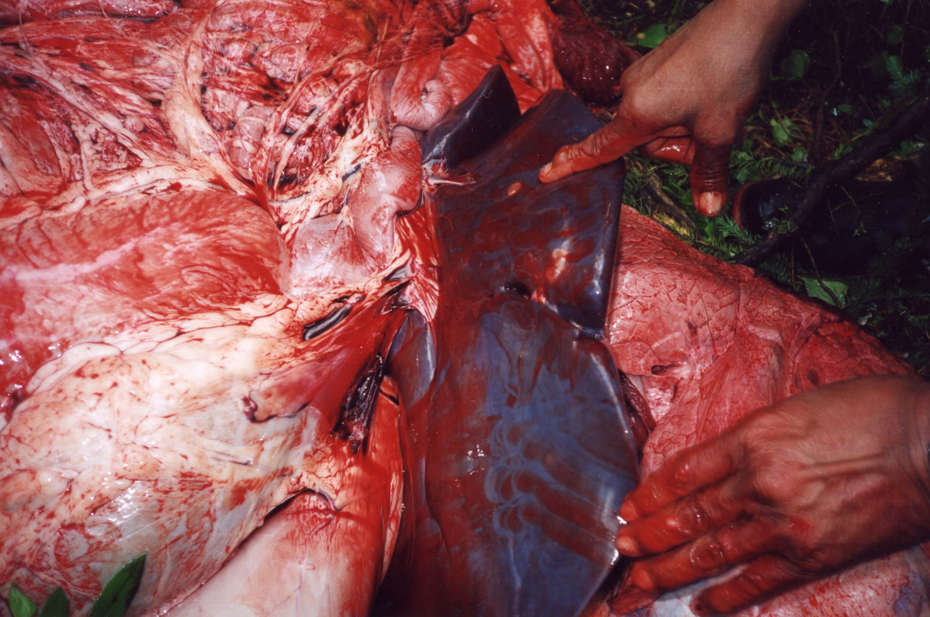
Figure 1: Cow Moose Liver Cyst

Elk Submission # 102/02023
The Elk kill was discovered at a hunter’s campsite along the 156 road on July 30, 2002.

Visual Assessment
The body was very fresh and estimated to be shot from the evening or day before. The internal organs looked normal and healthy.

Interpretation of Lab Results
No microscopic lesions were found therefore all tissues submitted were normal and healthy.

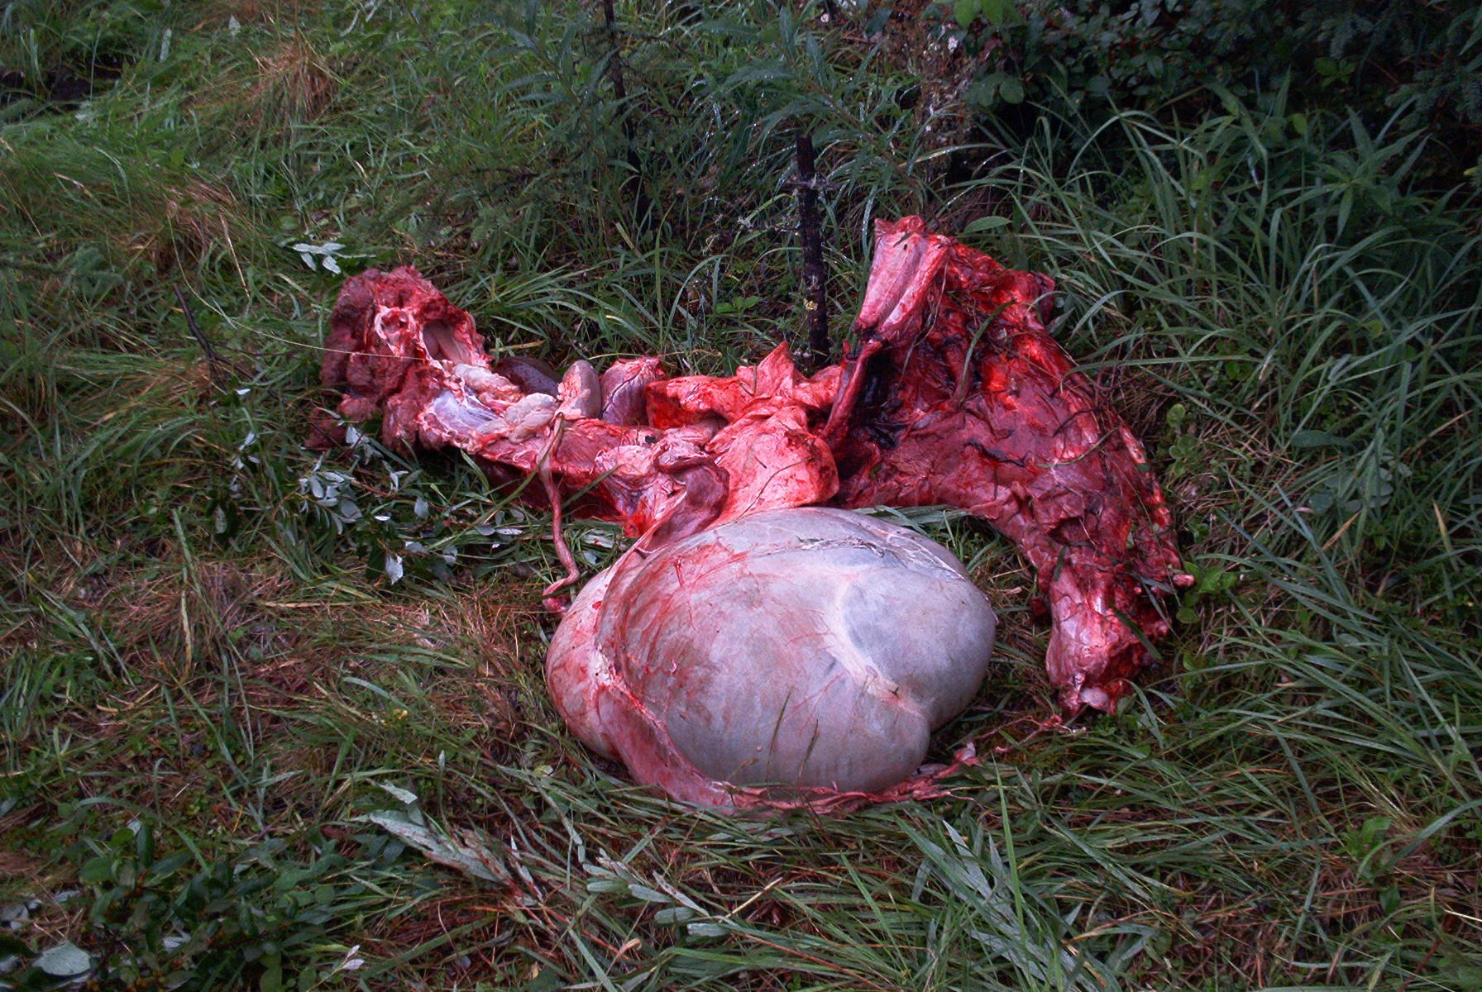

Bull Moose Submission # 102/03806
The Bull Moose was approximately four years old and was harvested on September 26, 2002 in a riparian area just down slope from a well site off of the 171 road.

Visual Assessment
The young Bull Moose harvested was in excellent condition. No observable external lesions or abnormal body fluids. The liver looked normal except for ten small white cysts on the surface. These lumps appeared to be clear, fluid filled sacs (0.5 x 0.5 cm) with a small white substance inside. The lungs appeared normal except for two hard lumps on the surface approximately 3cm x 3 cm. The heart also appeared normal except for two hard lumps located on the surface.

Notes and photographs were taken of the condition of the hide (external) and organs (internal).

Interpretation of Lab Results
The cysts which occur on the liver and lungs are parasitic infections by cestode (tapeworm) larvae. The lumps on the lungs are areas of inflammation or abscesses. Since they were discrete and there was no other noticeable problem they were most likely due to bacteria localizing in the lung and could have been a result of an infection from elsewhere such as a fighting wound (pers. comm. H. Schwantje).

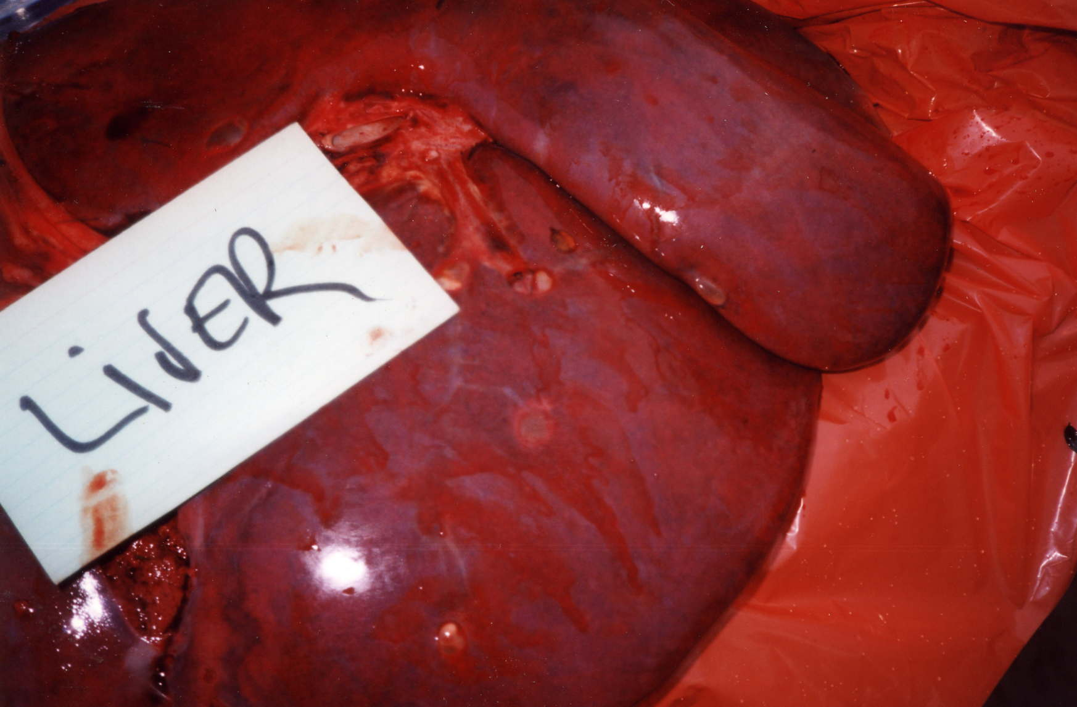
Figure 2: Bull Moose Liver

Young Cow Moose Submission # 102/3806
The young cow moose was approximately one year old and was harvested on Septembe 27, 2002 just of the 156 road past the Sikanni Compressor Station.

Visual Assessment
The young cow was in good condition. No observable external lesions or abnormal body fluids. Once the animal was skinned, an injury was observed on her right thigh. The injury was approximately 15 x 15 cm in area and consisted of a hemorrhage of the subcutaneous tissues and muscle possibly the result of a fight with a bull moose.

Another noticeable abnormality was the presence of a portion of the liver herniating out of the body cavity proper, under the skin. The liver capsule of this portion was grayish/blue in colour. The kidneys and heart appeared in good condition however there were two lumps found beside uterus which are likely paraovarian cysts (Pers. Comm. H. Schwantje). The lungs were free of lumps however an area of dark purplish discoloration was noticed in the cranial lobe of one of the lungs, an area of approximate 5 x 6 cm.

Interpretation of Lab Results
The cysts in the lungs are those of Echinoccocus spp. The cysts in the liver resemble those of other cestodes such as Taenia spp. The discoloration of the lung was an alveolar and interlobular hemorrhage which was likely the result of blood aspirating during death. The portion of the liver extending outside of the abdominal cavity is likely the result of an abdominal hernia from trauma and a piece of the liver had everted through a tear in the abdominal muscle wall. The color change was likely due to the age of the injury, so likely happened at the same time as the hemorrhage on the right thigh.

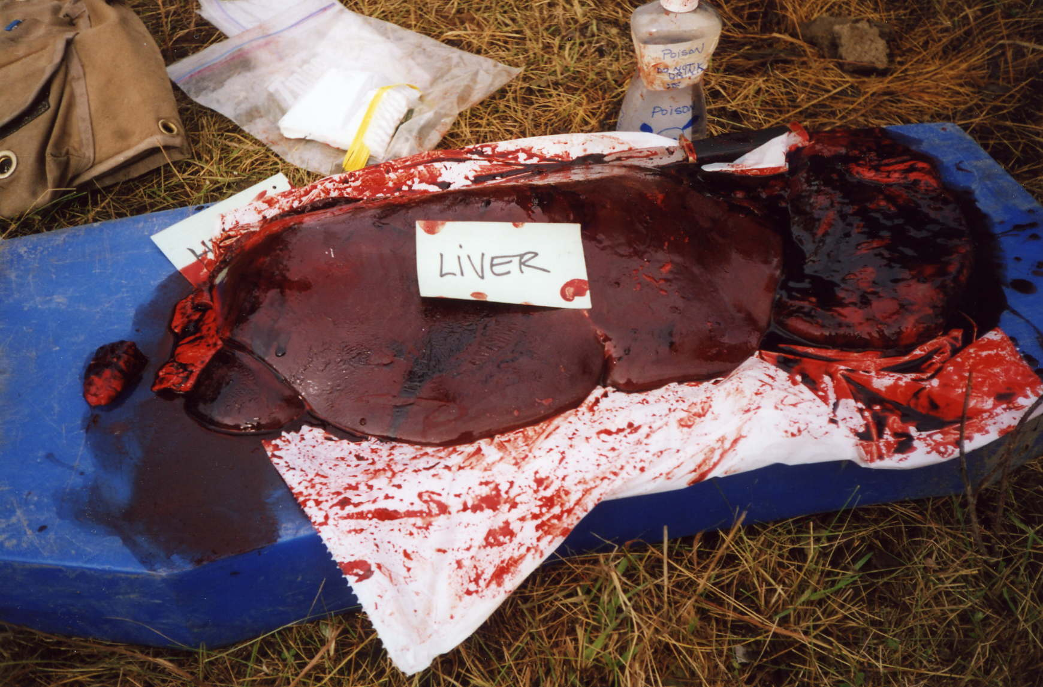
Figure 3: Young Cow Liver

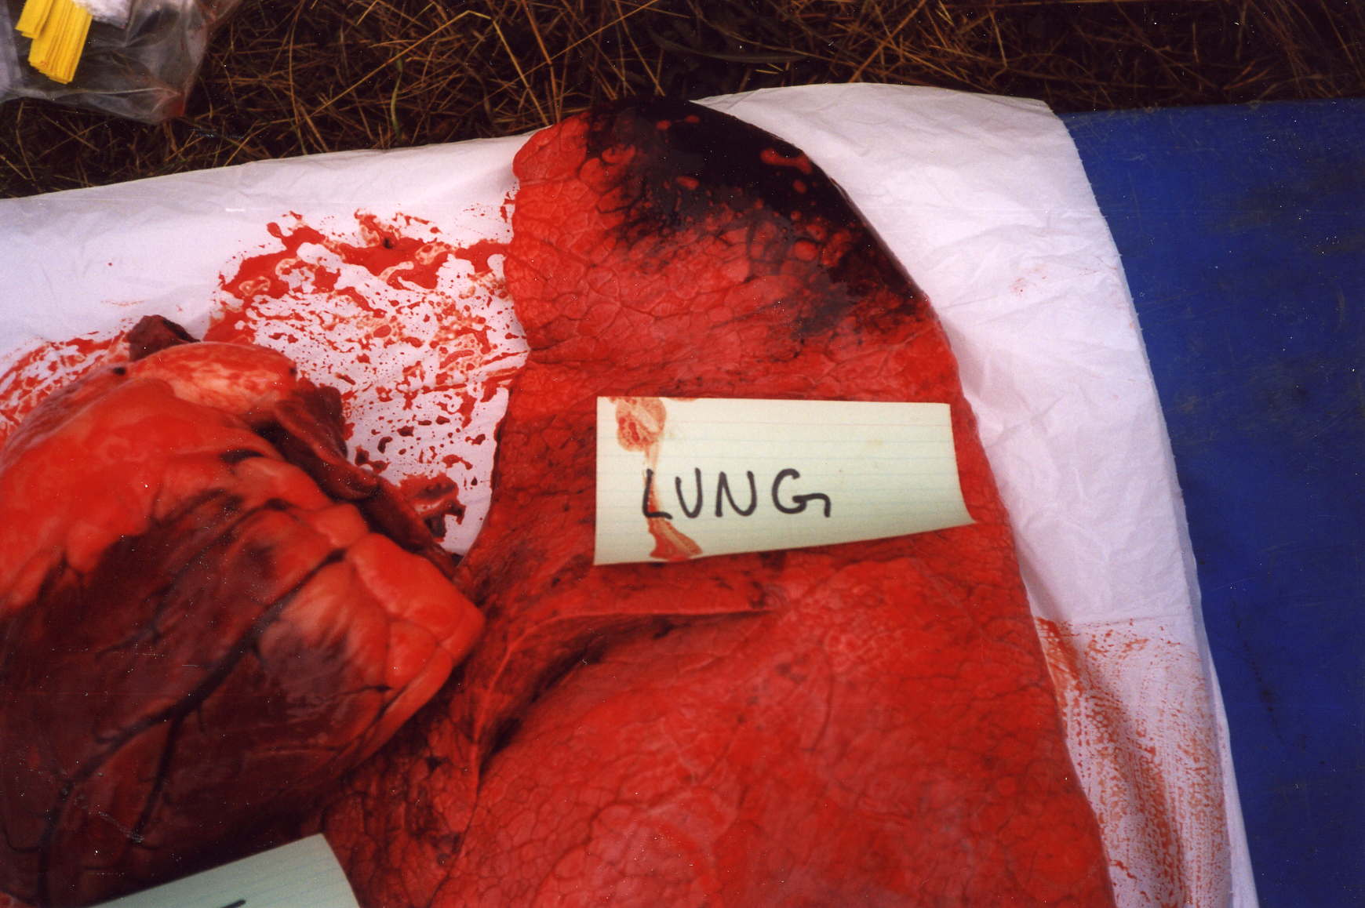
Figure 4: Young Cow Lung Showing Purplish Discolouration

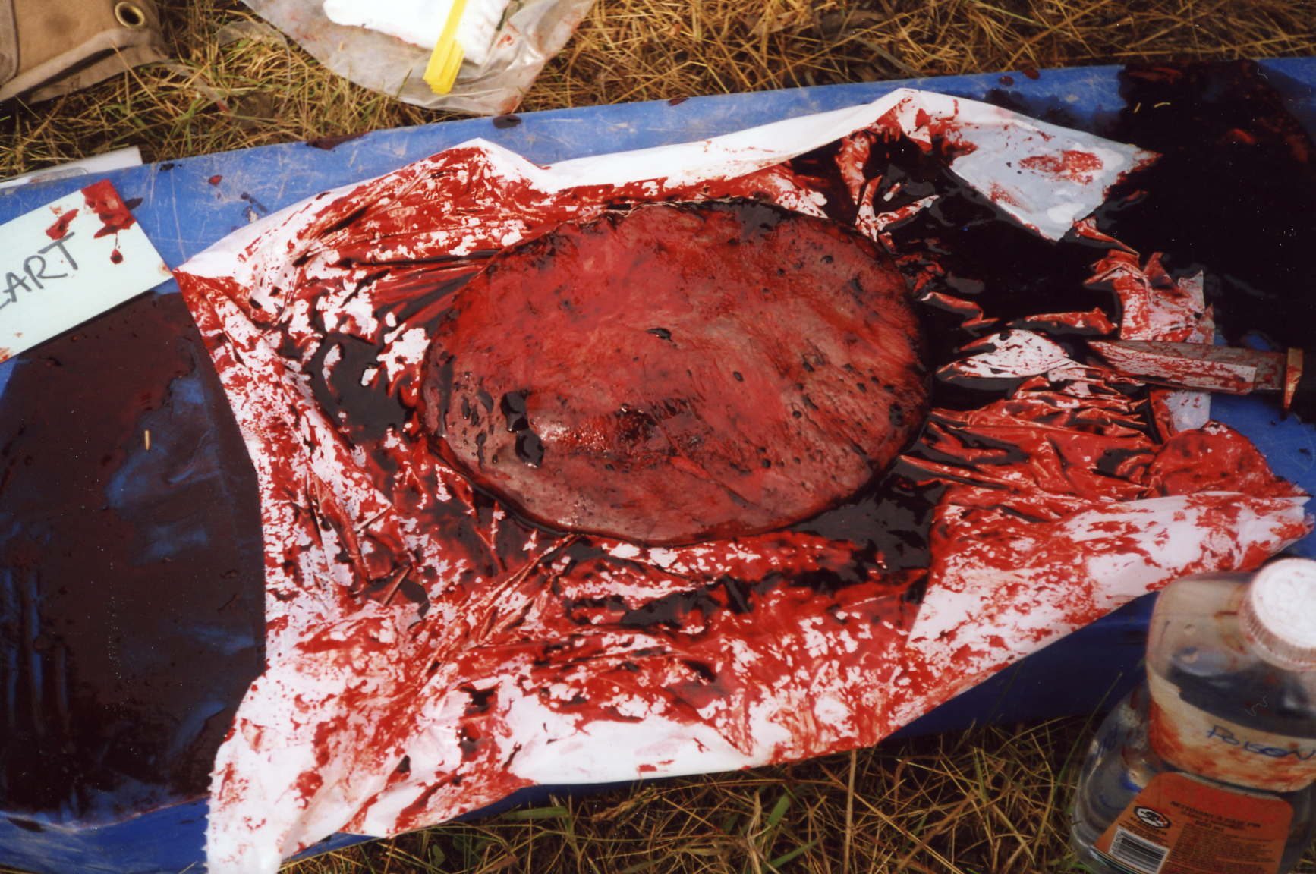
Figure 5: Young Cow Herniated Liver

General Habitat
The hunting area included the landscape east of Sikanni Chief River from La Prise creek to Tommy Lakes and west of Sikanni Chief River from Pink Mountain north to Buckinghorse and Nevis Creek.

The entire study area occurs within the Prince George Forest Region and can be characterized by various biogeoclimatic zones and subzones. Biogeoclimatic zones describe the type of plant communities that occur in relation to soils, geography and climate for a particular area. This is beneficial when describing wildlife habitat and relating the importance of wildlife habitat within a provincial context.

The study area occurs in the Boreal White and Black Spruce (BWBS) zone and the Spruce-Willow-Birch (SWB) zone. Within these zones, the following subzones occur:
BWBSmw1: Peace Moist Warm
BWBSmw2: Fort Nelson Moist Warm
BWBSwk2: Graham Wet Cool
SWBmk: moist cool

The provincial benchmarks for wildlife are habitat types that are rated as number one or “the best” for the entire province based on the criteria for providing food, shelter and other life sustaining requirements such as rutting and calving areas.

The provincial benchmark for Moose is divided into winter and growing season.

- Winter Benchmark: Boreal White Spruce – Trembling Aspen site located within the BWBSmw1 located in the Peace Lowland (PEL) ecosection

- Growing Season Benchmark: White Spruce-Balsam Poplar Riparian areas within the BWBSmw1 also located in the PEL ecosection.

Based on the above benchmark habitats, the study area is located within or near prime moose habitat for winter and growing seasons.

Moose Kill Habitat

Cow Moose
The cow moose was foraging at the time of death. She was spotted on a side road off of the Sikanni - 156 road. Observations confirmed that no calf was present.

The site is located within the BWBSwk2 at an elevation of approximately 1165 m. The habitat consisted of a thick, lush herb and shrub dominated ecosystem surrounded by a mature pine-spruce dominated forest. The site was gently sloped at 14% and the aspect was 136 degrees.

Some of the common species include red raspberry (Rubus idaeus), rose (Rosa acicularis), alder (Alnus sinuata), horsetails (Equisetum sylvaticum), cow parsnip (Heracleum lanatum), fireweed (Epilobium angustifolium), and grasses such as timothy (Phleum pretense), bluejoint (Calamagrostis Canadensis) and Kentucky blue grass (Poa pratense).

Bull Moose
The Bull Moose was in the company of a cow moose and both were discovered foraging in an open riparian wetland approximately 150 m down slope from a well site (Rigel Grassy Burner a-85-D/94-G-7). The location is just off of the 171 road and the area of harvest was near Grassy Creek.

The site has been classified as a shrub swamp located within the BWBSmw1. The site is characterized by widely spaced spruce trees less than 10 m tall. The understory is dense and thick consisting of shrubs such as scrub birch (Betula glandulosa) and willow (Salix sp.), less than 2 m tall. All of the willows were heavily browsed.

Sedges (Carex sp.) are the dominant herb and a thick carpet of moss (Tomenthypnum nitens and Sphagnum spp.) covers the ground. The terrain is hummocky and standing water occurs within small depressions.

The particular location at which the moose was harvested is almost level with a slope of 9% and an aspect of 310 degrees. Between this location and the well site, the ground rises up to the well site and is approximately a slope of 20%.

Young Cow Moose
The young cow was spotted drinking out of a shallow pond beside the 156 road just south of the Sikanni River yet past the Sikanni Compressor Plant. The shallow pond was situated in a disturbed clearing surrounded by a dense stand of young Spruce trees. The area is located in a within the BWBSwk2 however it is near the boundary to the BWBSmw1.

Several species which occur at the site are introduced species and have been established only since road development has taken place. The habitat is characterized by a variety of non-native herbs such as clover (Trifolium sp.) and grasses growing on hard compacted clay soils. Vegetation cover is not thick and exposed mineral soil is abundant.

Within a slight depression water has collected and created a somewhat small wetland environment around its perimeter. Species such as horsetails (Equisetum sp.), sedges (Carex sp.) and rushes (Juncus sp.) are common as are small willow shrubs less than one meter tall.

Well Sites
During the hunting session several well site locations were visited. The purpose of this was to determine if a) an open sump, flare pit or other drilling waste was present and b) if these areas were being used by animals.

Two specific incidents were documented by the Prophet River Band. On two separate occasions, at two different well sites during the summer of 2001, harvested moose appeared sickly, exuded a disagreeable odor and was deemed inedible. In addition to internal lumps which are most likely attributed to the normally occurring tapeworm cysts, symptoms included hair loss, weight loss (low fat content and exposed ribs), and abnormal fluids in the body cavity (greenish in colour). Prior to harvesting both animals were observed drinking out of sump ponds (pers. comm.. Paul Notseta).

Over the past few years the members of the Prophet River Band have noticed an increase in the occurrence of visual symptoms such as external lumps and believe this to be the cause of oil and gas activity.

Well Sites Visited
The well site locations below in Table 4 were investigated during the course of the hunting trip to determine if moose and other animals were indeed present at these sites. Based on tracks as well as feces, various species do in fact visit these areas. Species include deer, caribou, elk, sheep, grizzly bear and black bear.

The question arises then, what was the purpose of these visits and what kind of activity occurred at these sites? The only direct observation at a well site during the study was two deer grazing on grasses near Sikanni b-77L/94-G-2. No other direct observations were witnessed. In the past however Elders and other band members have noted moose and deer drinking the fluids out of sump and flare pits. Track abundance and patterns suggest that animals do not just walk in and walk out but actually spend a measurable amount of time at each well site, particularly within the sump pits themselves. The same tracks, indicated by size and condition, can be observed moving back and forth throughout the sump.

Evidence of drinking is hard to determine without visual data however evidence of licking the soil is very clear. At well sites where contaminated soil has been piled up, evidence of ungulates licking the soil is indicated by smooth marks on the ground surface in association with their tracks. These “licking characteristics” are readily comparable to natural salt licks.

It is conjectured in this study that ungulates are instinctively attracted to sumps, flare pits and drilling mud solids because of the concentration of salts that occur within these areas. These man-made areas then act as “pseudo-salt licks” for ungulates. Either by drinking or licking they obtain some of the essential trace minerals that are required for normal body function however, at the same time they may be ingesting other chemicals that by themselves, in combination or cumulative may cause negative side effects.

Other animals such as grizzlies and black bear sign were noted at these sumps and flare pits and it is assumed that they visit these areas because it is a source of drinking water. Soils throughout much of the study area are heavy in clay content thus permeability is very low. Water naturally accumulates in puddles and it is believed that animals have adapted to drink out of these water collecting sites. It just so happens that sumps and flare pits form another source of water collection or pseudo-ponds for wildlife.

 | Well Location | Documentation on File at OGC | Well Auth. # | Comments
1 | PC UPRI W Laprise  c-A14-J/94-G-8 | Notification of Drilling Waster Disposal Form | 0012233 | Moose and deer tracks
2 | PetroCan LaPrise  c-A7-E/94-H-5 | Notification of Drilling Waster Disposal Form | 0011922 | Sump Pit; moose tracks
3 | PC ET AL Mooselik  b-8-K/94-G-2 | Nothing on file | n/a | Location of sick moose kill, 2001 (P. Notseta).
4 | Ranger Sikanni  c-93 –I/94-G-3  (or c-41-I/94-G-3) | Sump Fluid Analysis | n/a | Location of 2nd sick moose kill, 2001 (P.Notseta)
5 | b-77-L/94-G-2 | Nothing on file | n/a | Open Flare Pit; moose tracks and orange water
6 | b-42-L/94-G-2  (or b-46-L/94-G-2) | Sump Fluid Analysis | n/a | Sump Pit
7 | Numac Sceptre Pocketknife  d-75-H/94-G-6 | Sump Fluid Analysis | n/a | Open Sump Pit; moose tracks
8 | MD 439  d-96-A/94-G-10 | Notification of Drilling Waster Disposal Form | 0012026 | 30 km on 185 road, three remote sumps with oil slick on surface.
9 | Talisman, Rigel Grassy Burner a-85-D/94-G-7 | Nothing on file. | n/a | No open sumps. Moose tracks
Table 4: Well Sites Surveyed by the Hunting Party.

Sump Analysis
The bioassay information for each sump associated with each of the natural gas well sites above was requested from the Freedom of Information branch at the Oil and Gas Commission. There were two types of files obtained from the Oil and Gas Commission, a new, more thorough waste disposal form and an older less detailed sump fluid analysis. Out of nine well sites, six had files and three did not. Out of those six with files three had the newer forms and three had the older forms.

The newer forms are called “Notification of Drilling Waste Disposal” and are based on the Alberta Energy and Utilities Board Guide 50: Drilling Waste Management guidelines which came out in 1996. These forms are a requirement when disposing of any drilling waste associated with a well site.

The Notification of Drilling Waste Disposal form details the location of the well site, the type of disposal methods required for both solid and liquid components and may be different for each, a list of elements (e.g. Cl, Na, Ca, Mg etc.) which occur in both liquid and solid samples and a list of mud products used. A Microtox Bioassay is completed for each sample. The result of this test must be equal to or greater than 75% in order to pass. If the sample fails, it must be run through a charcoal treatment after which the sample is re-tested. If a sample fails the charcoal test then the material must be treated to neutralize the toxicity.

The potential toxic components for each well site include mud products used as well as hydrocarbons added if necessary. Nine classifications of mud products have been identified as potential toxicants (Alberta Energy and Utilities Board, 1996). These are:

- Bactericides
- Corrosion inhibitors
- De-Foamers
- Emulsifiers and De-emulsifiers
- Foaming Agents
- Lubricants
- Polymer Stabilizers and Breakers
- Shale Control Inhibitors
- Surfactants

Not all products in the above categories exhibit toxic effects therefore the Petroleum Services Association of Canada (PSAC) maintain a Product Listing for Potential Toxicity. This listing contains toxicity assessment data for mud products in these classes at the concentrations at which they are normally used (Alberta Energy and Utilities Board, 1996).

The presence of hydrocarbons in drilling wastes can result in toxic effects. The Guide 50 (Alberta Energy and Utilities Board, 19916) lists five practices employed during drilling whereby hydrocarbons may be necessary.

- Disposal of Drill Stem Testing (DST) wastes to the sump
- Freeing a stuck pipe using hydrocarbons
- Kick, blow or well flow
- Drilling of a horizontal oil well
- Drilling of an under balanced well.

According to the Merck Veterinary Manual (1998), ingestion of hydrocarbon mixtures may cause illness or death. Typically the greatest danger is if the hydrocarbon is inhaled causing pneumonia. Viscous (thick and sticky) fractions of hydrocarbons such as oils are less likely to be aspirated (inhaled) therefore are less toxic. However the manual suggests that lubricating oils and greases tend to be hazardous more because of toxic additives or contaminants such as highly chlorinated naphthalens, lead and on occasion tetrachlorodibenzodioxin (TCDD).

Diagnosis of hydrocarbon poisoning can be determined from hydrocarbon odor in the lungs, stomach contents and feces. It is recommended that samples of the GI (gastrointestinal) contents, lung, liver and kidney should be collected for chemical analysis to demonstrate presence of hydrocarbons in the tissue, particularly the lungs.

An example is given for livestock stating that “cattle, and less frequently sheep and goats, may ingest hydrocarbons because they are curious or seeking salt or other nutrients….A cow may consume several gallons at one time” (page 2097, Merck Veterinary Manual). This provides some credence to the theory that wild game species may be seeking out salt laden sump pits as well in order to obtain salt and other nutrients, i.e. pseudo-salt licks.

Below a summary for each well site is given after having reviewed the newer waste disposal form as well as the older and less detailed, sump fluid analysis forms. Well sites are listed in the same order as they appear in Table 4.

c-A14-J/94-G-8
Four remote sump assessments are given for this one well site. The first remote sump contained mud products including De-Foamers, Chembreak and Xcide while the microtox bioassay passed at a 100% (EC50(15)=100%). The second remote sump had no mud products used while the Microtox bioassay failed the first test but passed the charcoal test. This particular sump contained 56 mg/L of and comments included that the hydrocarbons were slightly visible on the surface at time of sampling. The recommended treatment was to skim off all visible oil prior to disposal.

The third remote sump contained an Xcide mud product and passed the microtox bioassay with 100%. The fourth remote sump also contained the mud product Xcide and passed the microtox bioassay with 100%. All of the bioassays at this well site were conducted in 1999.
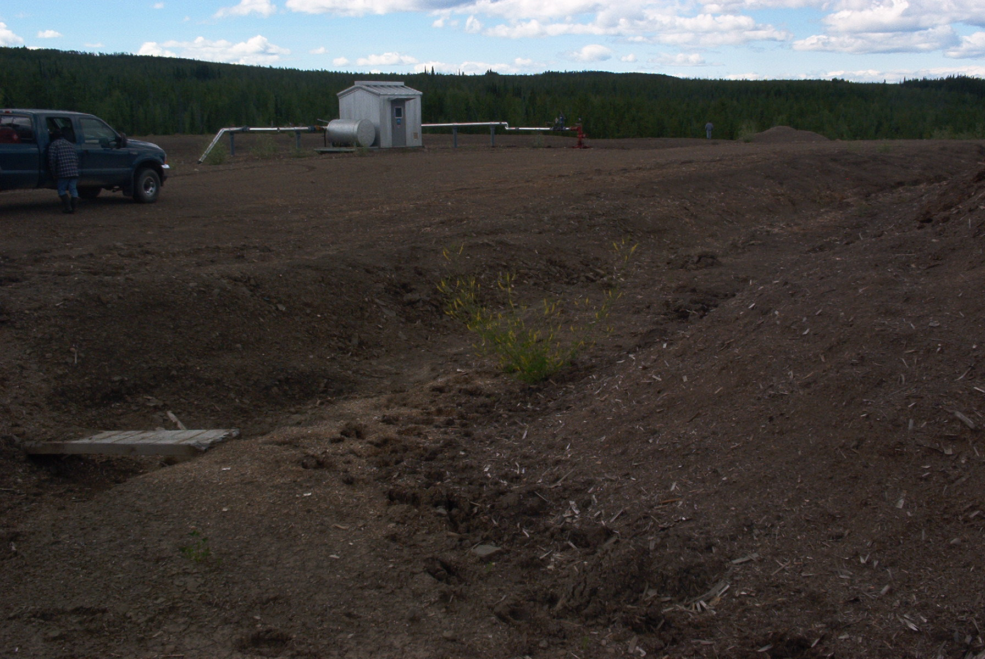
Figure 6: Moose tracks in soil pile.

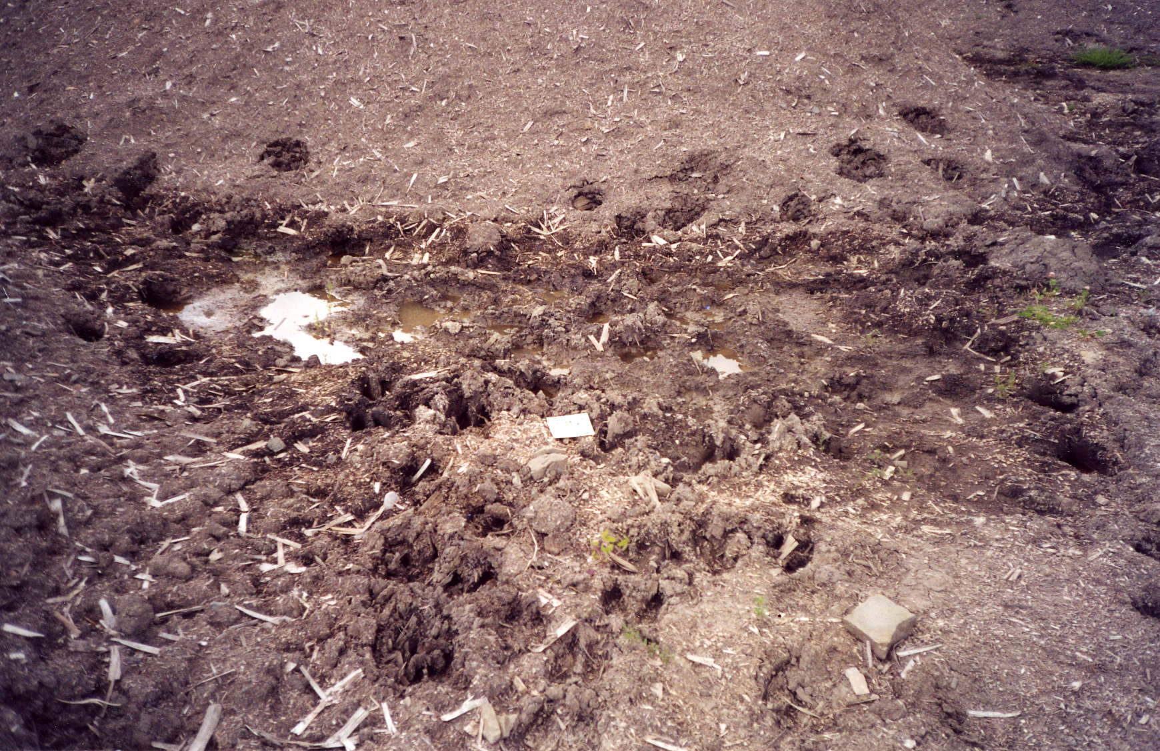
Figure 7: Moose Tracks

c-A7-E/94-H-5
During July of 2000, three sumps and a berm pile were assayed. No mud products were used and the Microtox Bioassay passed with 100%. No hydrocarbons were noted.

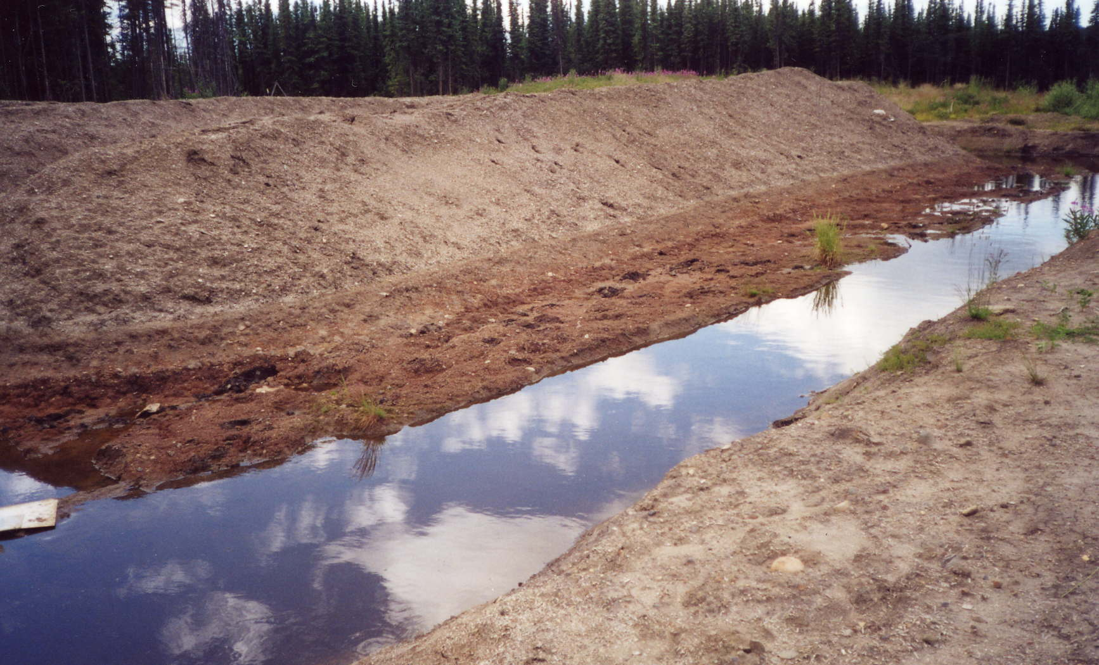
Figure 8: Moose Tracks in Mud

b-8-K/94-G-2
There was nothing on file for this site. 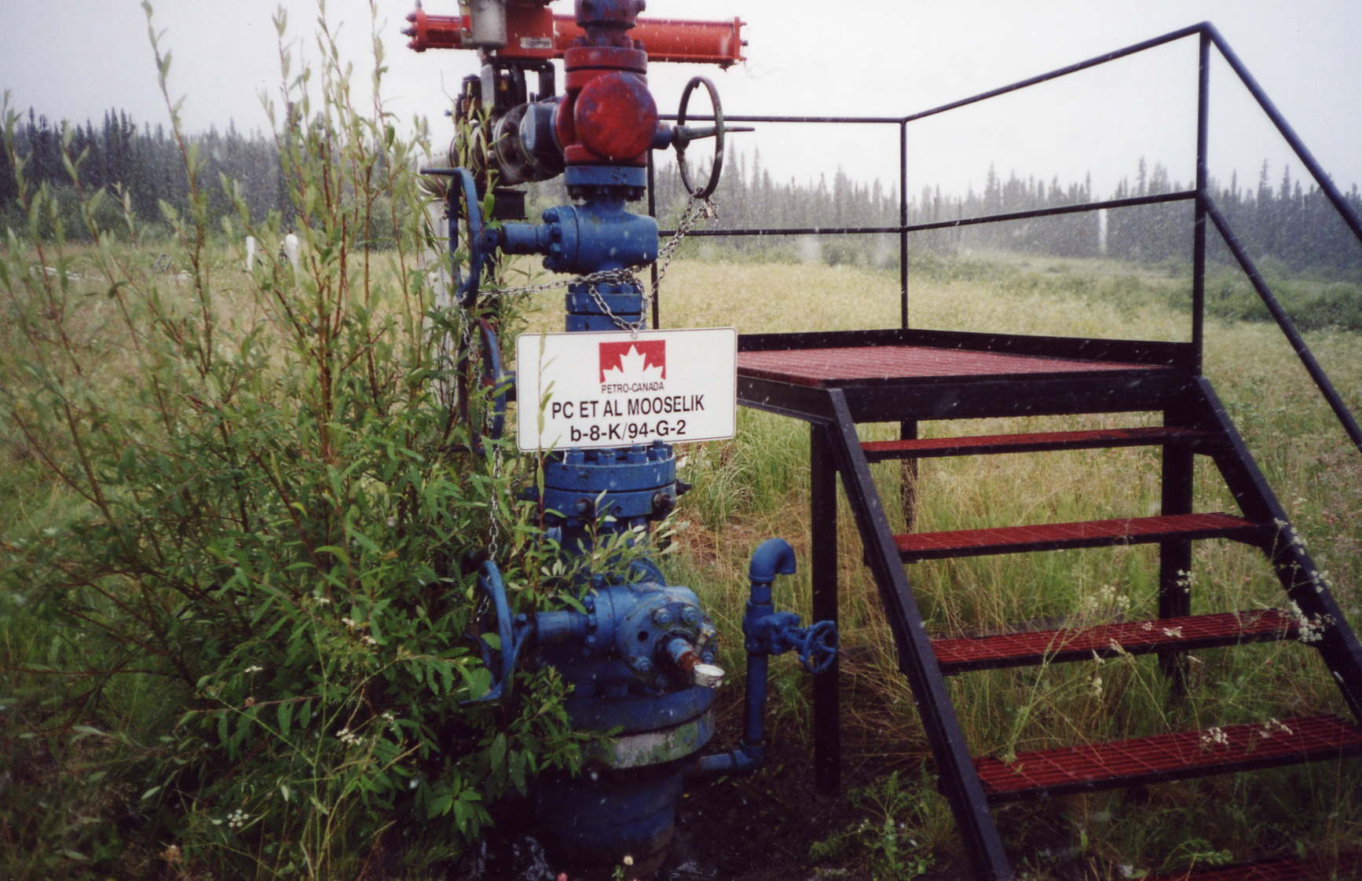
Figure 9: Location of Sick Moose Kill (P. Notseta).

c-93-I/94-G-3 (c-41-L/94-G-2)
The sump analysis at this site was completed during May of 1989. The Bioassay analysis consisted of taking three, one centimeter long fish at an average weight of 1.0 gram and submersing them in the sump fluid. At specific time intervals the % mortality was recorded. At this particular site after 96 hours there was zero mortality.

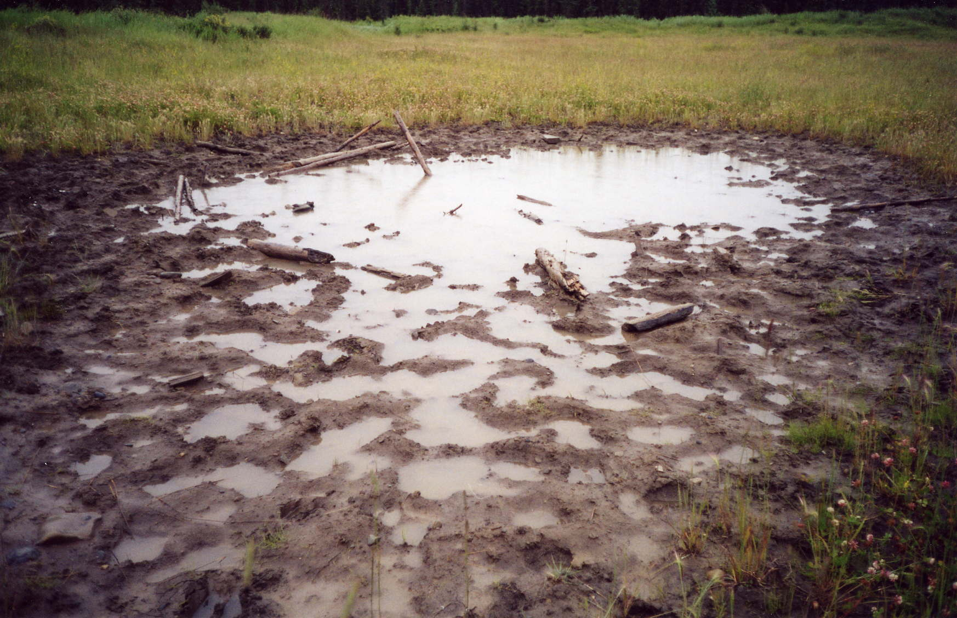
Figure 10: Moose Tracks in Mud.

b-77-L/94-G-2
There was nothing on file for this site.

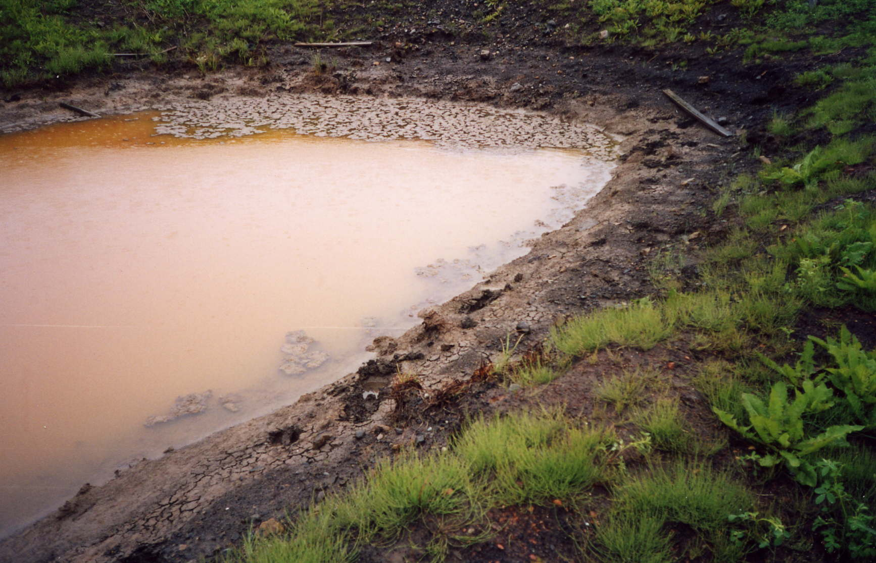
Figure 11: Old Flare Pit Filled with Water

b-42-L/94-G-2( b-46-L/94-G-2)
Only one page is presented for this sump analysis conducted in 1985. The concentration of particular elements is given with no more information.

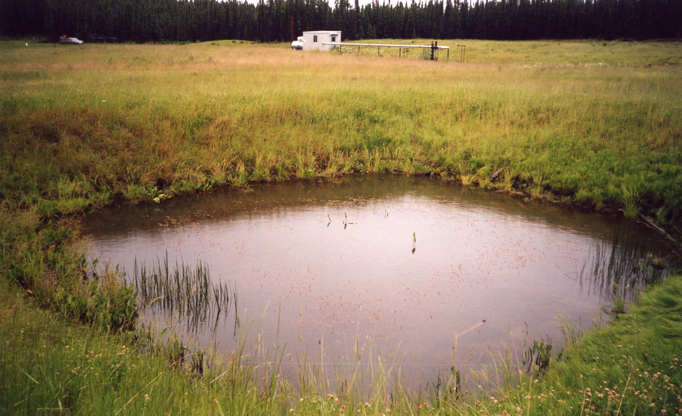
Figure 12: Open Flare or Sump Pit

d-75-H/94-G-6
For this particular site the bioassay was conducted in 1991 and consisted of taking three rainbow trout fingerlings and placing them in 1.0 liter of sump fluid. After 96 hours there was zero mortality. It was noted that no hydrocarbons were evident at time of sampling.

d-96-A/94-G-10
No mud products were used and the Microtox Bioassay passed with 90%. On March12, 1999, 2.6 mg/L of oil and grease were detected in the water analysis.

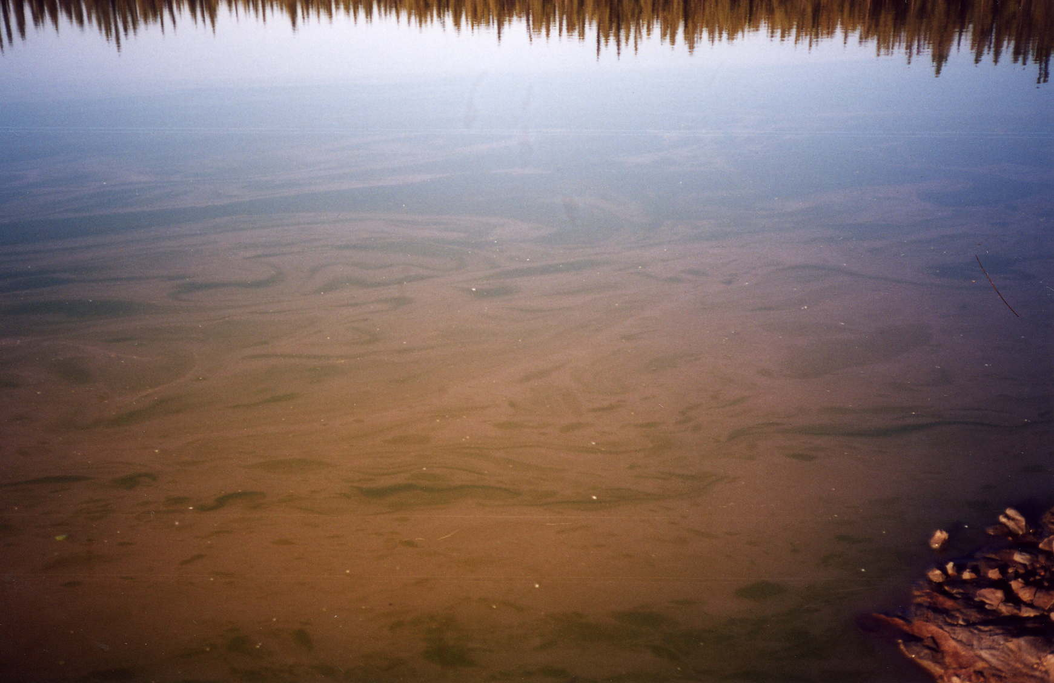
Figure 13: Sump Pit – 185 road

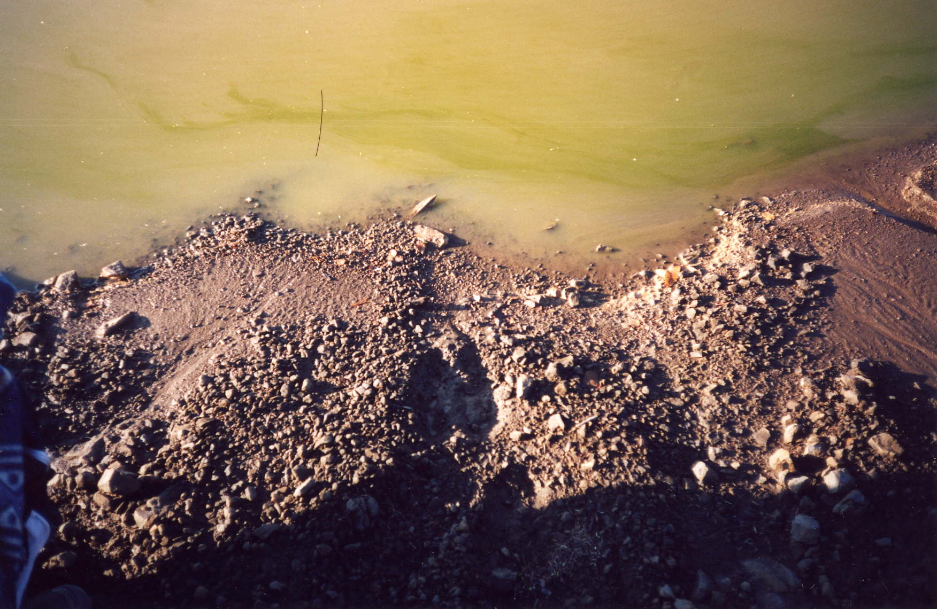
Figure 14: Moose Tracks Leading Into Sump Pit – 185 road

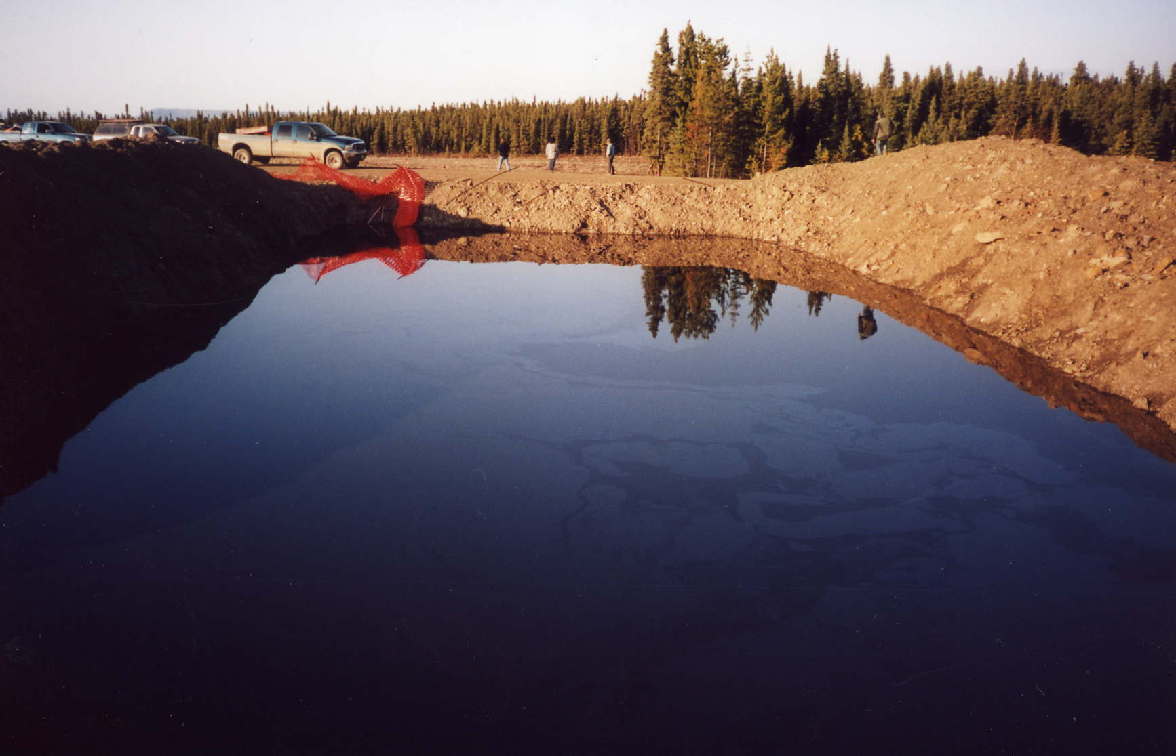
Figure 15: Sump Pit: 185 road

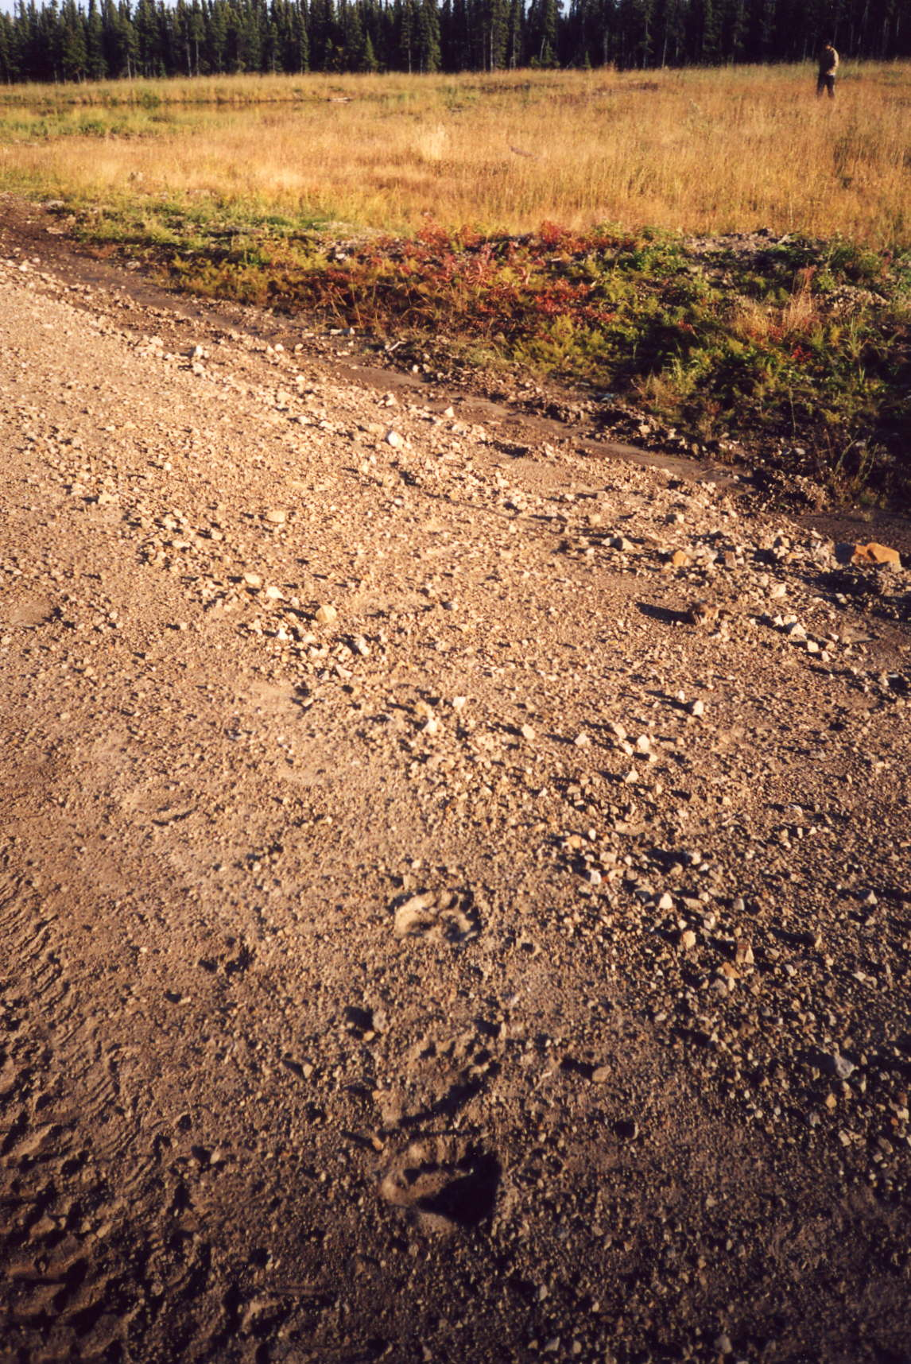
Figure 16: Grizzly Bear Tracks Coming Out of Sump Pit -185 road

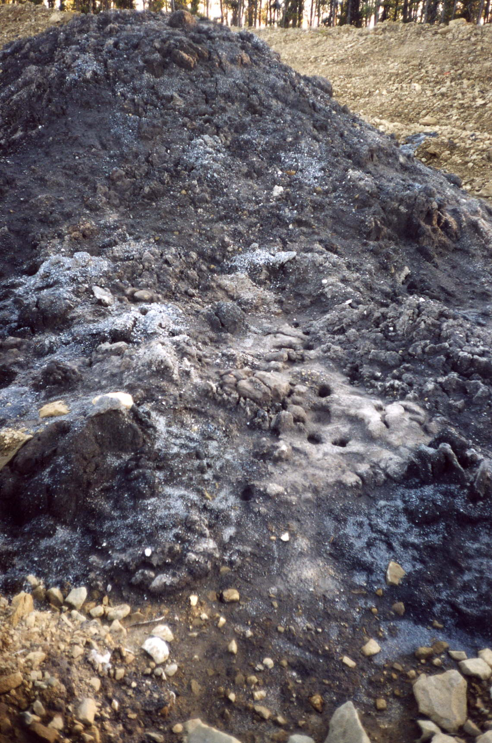
Figure 17: Sign of Animals Licking Waste Disposal Solids – 185 road

a-85-D/94-G-7
Rigel Grassy Burner. Well head, no open sumps. Moose tracks on site. Harvested Bull Moose downslope from this area.

Discussion
The following section summarizes the finding of the study and addresses how the two objectives were met for the study.

Objective One
Cysts found on the internal organs of each of the harvested animals were indeed caused by tapeworms. No evidence of anything atypical was found in any of the four carcass samples. Cysts, suspected to be caused by tapeworms, were found on the internal organs (liver, lung and heart) and based on the lab results these were indeed naturally occurring Cestode (Tapeworm) cysts primarily of the Echinococcus granulosus species and to a lesser extent the Taenia species.

No lumps or abnormalities were found on the external surface, the coat and skin of all three moose harvested appeared normal and in good condition No papillomas (warts) or fibromas (fibrous lumps) were found on the surface. The lumps on the lung were symptoms of bronchopneumonia. This is essentially a lung infection affecting the airways that had been present for some time. There is no impression of the cause, but it could be bacterial (H. Schwantje).

The numbers of tapeworm eggs were fairly high but that is not an unusual finding. Some animals in a population seem to have high tapeworm counts while others do not. Interpretation without knowing baseline values for a given population is difficult. To sum up, “None of what was found is unusual and appears to be common in moose harvested from areas where tapeworm primary hosts occur. If anything, the infections appear light” (H. Schwantje).

Objective Two
No direct correlation can be drawn with respect to oil and gas activity and moose health at this time and with a sample size of three. However this does not exclude the possibility that there may still be a correlation between ill health and oil and gas drilling waste given that drilling waste sites can be toxic as well as accessible to wildlife.

According to the Alberta Energy and Utilities Board, nine classifications of mud products are identified as potential toxicants and these mud products are commonly found in sumps. The particular mud additive of concern with respect to sumps in this area is hydrocarbons. Ingestion of hydrocarbon mixtures has been documented to cause illness and death in cattle (Merck Veterinary Manual).

Over time, ingestion of chemicals from any of these three sites may lead to health problems for not only moose but all wildlife species. There is direct evidence to suggest that a variety of wildlife species visit these well sites as indicated by tracks. Photographs were taken of tracks leading in and out of sumps, flare pits and well waste disposal piles. Animal tracks not only lead in and out of these areas but occur in abundance suggesting that the length of each visit is an extended period of time and not just a brief walk-through.

During this project no animals were noted to be drinking out of sumps however first nations people have observed this behavior in the past. These observations are documented by First Nations people not only from the Prophet River Band but also as far as the Saulteau Band out of East Moberly. This has raised concern regarding ill effects in wildlife populations occurring near oil and gas fields and ultimately raises long term health effects upon meat consumption by humans.

Not all sumps, flare pits or drilling waste solids are toxic but a certain proportion of these sites are. And not all of these sites are exposed and accessible to wildlife for extended periods of time however some are. It is therefore necessary to determine which sites are toxic and for how long they are exposed to the environment and wildlife.

Recommendations
The recommendations below have been provided to address the issue of wildlife exposure to potentially toxic sites, namely sumps, flare pits and drilling waste solids. The recommendations given are considered to be the most cost effective way to deal with these issues however if other methods arise, all solutions should be considered. The recommendations are:

- To determine the number of toxic sites
- To determine the length of exposure of each site to wildlife
- To determine the best strategy to deal with toxic sites

Determine the Number of Toxic Sites
The first issue to be addressed is to determine exactly how many sites out there are toxic. This is preferably established immediately upon completion of active drilling. All potentially toxic sites associated with a particular well such should be tested to determine if indeed they are toxic, to what level and by what chemical(s). Remote sumps should be tested on an ongoing basis at established intervals.

Determine the Length of Exposure of each Site to Wildlife
It is necessary to determine the length of exposure of each site to wildlife populations. In some cases toxic sites may be dealt with and disposed of immediately. However it is not always feasible to deal with waste products immediately and these can therefore be exposed to the environment for lengthy periods; in some cases years.

What is the average length or duration of time from drilling commencement to disposal of toxic sites? And what is the minimum and maximum range of time that these sites are exposed? These questions need to be answered. For whatever reason, in the event that a toxic site cannot be dealt with immediately some form of treatment or barrier should be considered.

Determine the Best Strategy to Deal with Toxic Sites
In the event that a toxic site must sit for an extended period of time before it can be disposed of, a strategy to deal with it needs to be developed. Two options provided: One, skim off the hydrocarbons and treat the site to neutralize the toxins that are present and two, build a physical barrier to prevent access to wildlife into these sites.

The first method is practical and likely the most cost effective. It is feasible to treat a toxic site immediately upon commencement of drilling activity until the site can be properly disposed of by any of the methods described in the Guide 50: Drilling Waste Management document.

The second method is somewhat more costly however in the event that the first option is not possible then some sort of physical barrier needs to be constructed to prevent animals from entering into these toxic sites. The most effective physical barrier is a fence design. The fence needs to be strong enough to withstand the physical pressure exerted by a moose and high enough to prevent a deer from jumping over top of it. This means that a snow fence will not suffice. Various designs and materials should be experimented with on the first few sites to determine the most effective and least expensive fence structure.

Further Studies
Future studies are required to better understand the interactions of wildlife and oil and gas activity and the potential impacts on wild game populations. A dual approach is recommended, monitor the wildlife and monitor the well sites.

Monitor Wildlife
For example, remote cameras installed at specific locations are an excellent method whereby wildlife behavior can be observed and recorded with minimal human disturbance. This will provide helpful insight into the activities of wildlife at each site. It will help to determine the exact nature of their visits, how much time they spend there and do they drink the water or do they just move through. Obviously it is hypothesized that they do drink the water but how many animals that visit the site have a drink and how much.

Another way to monitor wildlife is to collect baseline data. First, an estimation of population densities per area should be determined. A significant amount of this data is currently available through the Ministry of Water, Land and Air Protection. Second, establish a baseline level of health among the populations of various ungulates.

Questionnaires are useful to determine the condition of existing wild game populations. The sector of the population given the questionnaire will include local hunters, guide outfitters and First Nation’s Bands.

To further establish baseline health conditions fecal samples are a relatively easy and non-intrusive source of data to collect. On a regular basis samples can be collected from various areas and submitted for analysis. This will provide long term data and baseline information regarding normal parasite and hydrocarbon levels that occur within the game population. This will ultimately provide a benchmark for analysis and allow a means of comparison.

Monitor Well Sites
Long term monitoring of well sites is highly recommended to assess on an ongoing basis the status of each well site. Are there toxins on site, are they accessible and what is the best approach to dealing with these issues in a cost effective and timely manner. These are some of the important questions that need to be answered in order to determine the overall risk to wildlife.

Well sites that are deemed to be toxic and left exposed for extended periods should either be treated and neutralized or fenced off. Well sites should be monitored to determine the effectiveness of either method used. If treated and left exposed, the impacts on wildlife needs to be determined. If toxic sites are fenced off, fences should be checked regularly to confirm that they are still intact and in good condition throughout the seasons.

Conclusion
The elders are still concerned regarding the health of moose in the area however these concerns are somewhat alleviated in knowing that this issue is being taken seriously.

References
Aiello, E. Susan. B.S., D.V.M., E.L.S. 1998. The Merck Veterinary Manual. Eighth Edition. Published by Merck and Co., Inc. Whithouse Station, N.J. U.S.A. R 636.0896 MER

Alaskan Booklet. A Field Guide to Common Wildlife Diseases and Parasites in Alaska. Alaska Department of Fish and Wildlife. Wildlife Conservation. www.state.ak.us/adfg/wildlife/region5/guide/internal4.htm

Alberta Energy and Utilities Board. Guide 50: Drilling Waste Management. October 1996. Published by Alberta Energy and Utilities Board. www.eub.gov.ab.ca

C. DeLong, A. MacKinnon., and L. Jang. February 1990. A Field Guide for the Identification and Interpretation of Ecosystems of the Northeast Portion of the Prince George Forest Region. BC Ministry of Forests. Land Management Handbook Number 22.

Jenkins, Emily. 2002. Western College of Veterinary Medicine, University of Saskatchewan. Department of Microbiology. 52 Campus Drive. Saskatoon, SK. S7N 5B4.

Ministry of Agriculture, Food and Fisheries. Animal Health Centre. 2002. 1767 Angus Campbell Road, Abbotsford, BC, V3G 2M3. Accredited Laboratory.

Newfoundland and Labrador Agriculture. Animal Diseases. www.gov.nf.ca/agric/pubfact/moose.htm

Northwest Territories, Wildlife and Economic Development. A Field Guide to Common Wildlife Diseases and Parasites in NWT and Nunavut. www.nwtwildlife.com/publications/diseasepamphletweb/diseasesindex.htm

Oil and Gas Commission. Freedom of Information/Records Management Analyst. Fort St. John. Records obtained from Dana Warner.

Petroleum Services Association of Canada. 2002. Drilling Fluid Product Listing for Potential Toxicity Information.

Sample, B.E., Aplin, M.S., Efroymson, R.A., Suter II, G.W., and Welsh, C.J.E.. 1997. Methods and Tools for Estimation of the Exposure of Terrestrial Wildlife to Contaminants. Prepared for the US Department of Energy. Prepared by Oak Ridge National Laboratory, Oak Ridge, Tennessee.

Schwantje, Helen. Dr. Personal Communication. 2002. Wildlife Veterinarian with the Ministry of Water, Land and Air Protection. Victoria, BC.

Appendix: Detailed Analysis

Cow Moose (submission # 102/03022)

Sex: Female
Age: Approximately 2 years old
Location: 156 Road
GPS: N 6338799 E 0502033
Date Killed: July 30, 2002
Nearest Well site: B-42L/94-G-2

External Tissue Assessment
Hair: Good. No external lesions or hair loss evident.

Skin: Good other than a small area open sores on the rear left hind leg which appeared to be caused by insects. This is suspected to be caused by Moose Fly (Haemotobosca alcis). These flies are often found where moose occur and do not attack other members of the deer family. The flies bite the hindquarters of moose just above the hock. Hundreds of flies may attack a moose at one time which produce wet open sores (Alaskan Booklet, pg. 12).

Teeth: Good.

General Condition: Good. The cow moose was in healthy condition, no indication of malnutrition, disease or weight loss. Comments were made by the hunters that “she was fattening up very nicely for winter”.

Internal Tissue Assessment
Overall the amount of body fat deposits were good. The kidney was surrounded by a thick layer of fat approximately 2 – 3 cm thick.

Liver: 5 White Spots. Each spot looked like an air bubble, filled with fluid and a small piece of white material inside. Very small, approximately 0.5 cm x 0.5 cm, otherwise the liver looked normal and healthy.
Sample: 1 Formalin; 1 Frozen

Lungs: Four hard lumps on surface approximately 1 cm x 1cm in size; otherwise normal.
Sample: 1 Formalin; 1 Frozen

Kidneys: no cysts or lumps; normal.
Samples: 1 Formalin and 1 Frozen.

Heart: Normal. No samples.

Feces: feces were collected but were not sent in for analysis.

Lab Analysis
- Moose Lung: Bronchopneumonia, severe, multifocally extensive, subacute
- Moose Liver: Granuloma, moderate, focal, chronic with intralesional cestode.

The pneumonia and hepatic granuloma, if representative of a sufficiently large portion of lung and liver field, would have contributed significantly to antemortem morbidity and possibly the loss of this animal.

Elk (submission # 102/03023)

Sex: Unknown
Age: Unknown
Location: 156 Road
GPS: N 6345070 E 0495749
Date Found: July 30, 2002
Estimated day of kill: July 29, 2002

External Tissue Analysis
No external tissue were present at kill site.

Internal Tissue Analysis
All internal tissue appeared normal.
Liver and kidney were taken: one Formalin and one Frozen of each.

Lab Analysis
1. Liver: open, normal tissue
2. Kidney: open, normal tissue

Close evaluation of the sectioned tissue failed to reveal any microscopic lesions.

Bull Moose (submission # 102/03806)
Sex: Male
Age: Approximately 4 years old (three tines)
Location: 171 Road
GPS: Latitude 57 deg. 19 min. 14.1 sec. Longitude 122 deg. 56 min. 08.9 sec.
Date Killed: September 26, 2002
Nearest Well site: Rigel Grassy Burner a-85D/94-G-7

External Tissue Assessment
Hair: Good. No external lesions or hair loss evident.

Skin: Good. No bug bites, no lumps.

General Condition: Excellent. Bull moose looked very healthy.

Internal Tissue Assessment
Overall the amount of body fat deposits were good. The kidney was surrounded by a thick layer of fat approximately 2 – 3 cm thick and the pericardial fat was similar (around the heart).

Liver: Ten small “cysts” were found on the liver. Each “cyst” looked like an air bubble, filled with a mucous fluid and a small piece of white material inside. Very small, approximately 0.5 cm x 0.5 cm, otherwise the liver looked normal and had a healthy colour.
Sample: 2 Formalin; 2 Frozen

Lungs: Two hard lumps found on the surface of the lungs. They were approximately 3 cm x 3 cm in size.
Sample: 1 Formalin; 1 Frozen

Kidneys: no cysts or lumps; normal.
Samples: 1 Formalin and 1 Frozen.

Heart: Two hard lumps approximately 2 cm x 2 cm in size were found on the heart, otherwise it appeared normal. The heart was surrounded by a thick layer of fat in the pericardial sac.
Samples: 1 Formalin and 1 Frozen.

Fecal Analysis
The Baermann test was negative, as was the liver fluke test.

Eggs of gastrointestinal parasites, Nematodirus spp. were found.

Lab Analysis
- Tapeworm cyst (Cysticercus)

“Liver – there is a large cyst that is compressing the surrounding hepatic parenchyma. This cystic structure is partially lined by a thick layered cuticle with a basement membrane and no recognizable internal structure. Serial sectioning of this cyst fails to reveal any different morphology.”

“Lung – there are large cestode larval cysts that are composed of a very thick layered cuticle lined by a basement membrane with free-floating calcareous corpuscles as well as numerous aggregates with “seeds or sand” that contain individual hooks and calcareous corpuscles.”

“Kidney – no visible lesions.”

General Comments
“The cysts present are those of cestode larvae, unfortunately there are few diagnostic characteristics within these cysts which precludes positive identification.”

Young Cow Moose ( submission # 102/03806)
Sex: Female
Age: Approximately 1 year old
Location: 156 road
Latitude: 57 deg 13 min 49.3 sec
Longitude: 123 deg 02 min 32.5 sec
Date Killed: September 27, 2002

External Tissue Assessment
Hair: Good. No hair loss evident.

Skin: Good. No external lesions.

General Condition: Good. This young cow moose was in good condition except for the trauma noted with no indication of malnutrition, disease or weight loss.

Internal Tissue Assessment
Overall the amount of body fat deposits was good. The kidney was surrounded by a thick layer of fat approximately 2 – 3 cm thick. The pericardial fat had a moderate amount of fat, approximately 1 cm thick.

Liver: A small portion of the liver was found external to the body cavity. It was found on the upper right hand side of the body underneath the skin but outside of the abdominal cavity. It was not another organ, but had herniated due to trauma. Portions of this area were collected for analysis. Three small (0.5 cm x 0.5 cm) fluid filled cysts were found on the internal liver otherwise the organ appeared normal.
Sample: 2 Formalin; 2 Frozen

Lungs: Large purple discoloration on right cranial lobe.
Sample: 1 Formalin; 1 Frozen

Kidneys: no cysts or lumps; normal. A thick (2 -3 cm) layer of fat surrounded each kidney
Samples: 1 Formalin and 1 Frozen.

Heart: Normal. No samples.

Right Rear Thigh: Large bruise (muscle hemorrhage) with puncture wound through skin.
Samples: 1 Formalin and 1 Frozen.

Uterus horn: Two hard lumps were found beside the uterine horn. These were paraovarian cysts, they are near the ovary and developmental (Pers. Comm. H. Schwantje). Unfortunately this sample was lost and no analysis was conducted.

Fecal Analysis
The Baermann test was negative, as was the liver fluke test.

Eggs of gastrointestinal parasites, Nematodirus spp. were found.

Tapeworm eggs were found. These are possibly Moneizia spp. “The numbers of tapeworm eggs are fairly high but again that is not an unusual finding – some animals in a population seem to have high tapeworm egg counts while others have none. Again, interpretation without knowing the normal values is tricky” (U of Sask., comments).

Lab Analysis
Tapeworm cyst (Cysticercus)

“Liver and heart – there are cysts that contain cestode larvae that have a thick cuticle lined by a basement membrane with some invagination of the cuticle. There is no digestive tract but often numerous calcareous corpuscles. “

“Lung – marked alveolar and interlobular hemorrhage. In some sections there is marked peribronchiolor muscular hyperplasia.

General Comments
“…the cysts in the lung are those of Echinococcus spp. The cysts in the liver resemble those of other cestodes such as Taenia spp. “

