Assessment of Atmospheric S Deposition to and Proportion of S in Surrounding Ecosystems due to Sour Gas Emissions

Report I: Background S and Source Characterisation

by:

A.L. Norman¹, B. Mayer¹, E. Bradley²

¹Department of Physics and Astronomy
²Department of Civil Engineering
The University of Calgary
2500 University Dr. N.W.
Calgary, Alberta T2N 1N4

Prepared for:

The B.C. Oil and Gas Commission

June 2002

Abstract

The cumulative impact of sulphur emissions from sour gas flaring and/or processing on soil and vegetation can be assessed using stable isotope techniques if source and receptor environments have sufficiently distinct, and uniform, sulphur isotope compositions. Airborne sampling is able to apportion the impacts of emissions for multiple, but isotopically distinct, sources. Larger isotopic differences between sources and receptors provide better isotopic leverage to resolve anthropogenic sulphur inputs. This study examined the sulphur isotope composition of non-impacted sites and emissions to assess the potential for using isotope leverage techniques in ecosystems in northeastern British Columbia. Isotopic leverage was greatest in the Fort Nelson area. Elemental sulphur δ³⁴S values (representing emissions) at the Fort Nelson gas processing plant were +16 ‰ whereas soils and non-impacted vegetation were isotopically negative, ranging from –6 to –4 ‰. In contrast, δ³⁴S values for sulphur emissions from Pine River were much closer to that for soils at non-impacted sites, with δ³⁴S_{e} = +11 ‰ versus +4 ‰, respectively. It is interesting to note that at one site downwind of the Pine River processing plant isotope and concentration data for vegetation suggest that these trees experience significant sulphur stress. Other oil and gas extraction and processing facility emissions that were tested for this study had δ³⁴S values ranging from +2.4 ‰ to +15.2 ‰. No sites were identified where sulphur impacts from more than a single emission source could be investigated. The combination of very low sulphur content and small differentiation in the isotope composition of emissions precludes using sulphur isotopes for tracing multiple emission sources at any of the sites examined. However, cumulative and current impacts of sulphur from processing plants on air quality and surrounding ecosystems can be assessed for single sources. The large isotopic leverage between source and receptor in the Fort Nelson region makes this an attractive site for further study.

Acknowledgements

This study was supported by funds from the B.C. Oil and Gas Environmental Fund. The authors extend their thanks to Anadarko Petroleum Corporation, BP Canada Energy, Coastal Gas Company, Devon Energy, Duke Energy, Imperial Oil, Petro-Canada, Williams Energy Canada, and staff for site access, willing participation, and source gas information.

Table of Contents

Abstract………………………………………………………………………………… i
Acknowledgements…………………………………………………………………… ii
Table of Contents…………………………………………………………………….. iii
List of Tables………………………………………………………………………….. iv
List of Figures…………………………………………………………………………. v

1. Introduction…………………………………………………………………………. 1
2. Study Area………………………………………………………………………….. 2
3. Atmospheric Sulphur Emissions………………………………………………….. 4
3.1. Characteristics of Sulphur Emissions………………………………………….. 4
3.2. Sampling Methodology………………………………………………………….. 4
3.3. Results……………………………………………………………………………. 5
4. Isotope Characteristics of Soils and Vegetation………………………………… 7
4.1 Methodology………………………………………………………………………. 7
4.2 Results…………………………………………………………………………….. 9
5. Conclusions…………………………………………………………………… ……10
6. References…………………………………………………………………………..11

List of Tables

Table 1. δ³⁴S values for elemental sulphur…………………………………. 5

Table 2. δ ³⁴S Values for Ambient SO₂………………………………………. 6

Table 3. δ³⁴S values of total sulfur in pine needles and soils from the
vicinity of the Pine River Gas plant…………………………………. 9

Table 4. δ³⁴S values of total sulfur in pine needles and soils from the
vicinity of the Fort Nelson Gas plant………………………………… 10

List of Figures

Figure 1. Isotope composition of sulphur sources in Alberta……………….. 2

Figure 2. Map of northeastern British Columbia and location of the gas
processing facilities where emissions were characterized……….. 3

Figure 3. Map identifiying the location of vegetation and soil sampling……. 8

1. Introduction

Gaseous and aerosol products, such as sulphur dioxide (SO₂) and sulphate (SO₄²⁻) released during oil and gas production, undergo oxidation and/or transport before deposition into the surrounding environment. Cumulative effects of sulphur deposition in surrounding ecosystems and the proportion of airborne pollutant deposited is difficult to distinguish on the basis of concentration measurements alone. However, differences in natural abundance sulphur isotope ratios between source and receptor sites can be used to identify and allocate anthropogenic sulphur inputs (Krouse and Mayer, 2000; Krouse, 1991).

Variations in natural abundances of light elements are based on the ratio of the rare (³⁴S) to common (³²S) isotope. The ratio for sample material is referenced to an international standard (VCDT) and since variations typically occur on the order of parts per thousand, this difference is amplified by subtracting one and multiplying by a thousand (Equation 1). Samples with less of the heavy isotope than the reference have negative δ values, while those containing more will be positive.

1) δ³⁴S = {(³⁴S/³²S)_{X}/(³⁴S/³²S)_{VCDT} – 1} x 1000

Isotope compositions at a receptor site can provide information about sources, and/or isotopically selective processes. The range in δ³⁴S values for hydrogen sulphide (H₂S) and sulphur in various sources within Alberta is shown in Figure 1. It should be kept in mind that these values represent many sites: the sulphur isotope composition from a single site or source, is often quite uniform. As an example, emissions from two sour gas plants near Calgary were sampled in the early 1980s. One plant had sulphur with δ³⁴S values at +18 ‰ and the other +28 ‰. Ten years later these same plants were sampled again and the δ³⁴S values for sulphur emissions were within a few ‰ of the original measurements.

Sulphur found in association with oil and gas formations in Alberta and British Columbia is of marine origin. Marine sulphate δ³⁴S values did not remain constant over geological time, but ranged from +10 to +35 ‰. Hydrogen sulphide from a given reservoir is expected to reflect that of source sulphate so long as reservoir temperatures are greater than 80ºC (Krouse et al. 1988). Below 80 ºC isotope fractionation may take place via bacterial sulphate reduction which favours the formation of isotopically lighter H₂S (Krouse, 1977a). These variations in source and formation processes result in reservoirs having unique δ³⁴S values for H₂S.
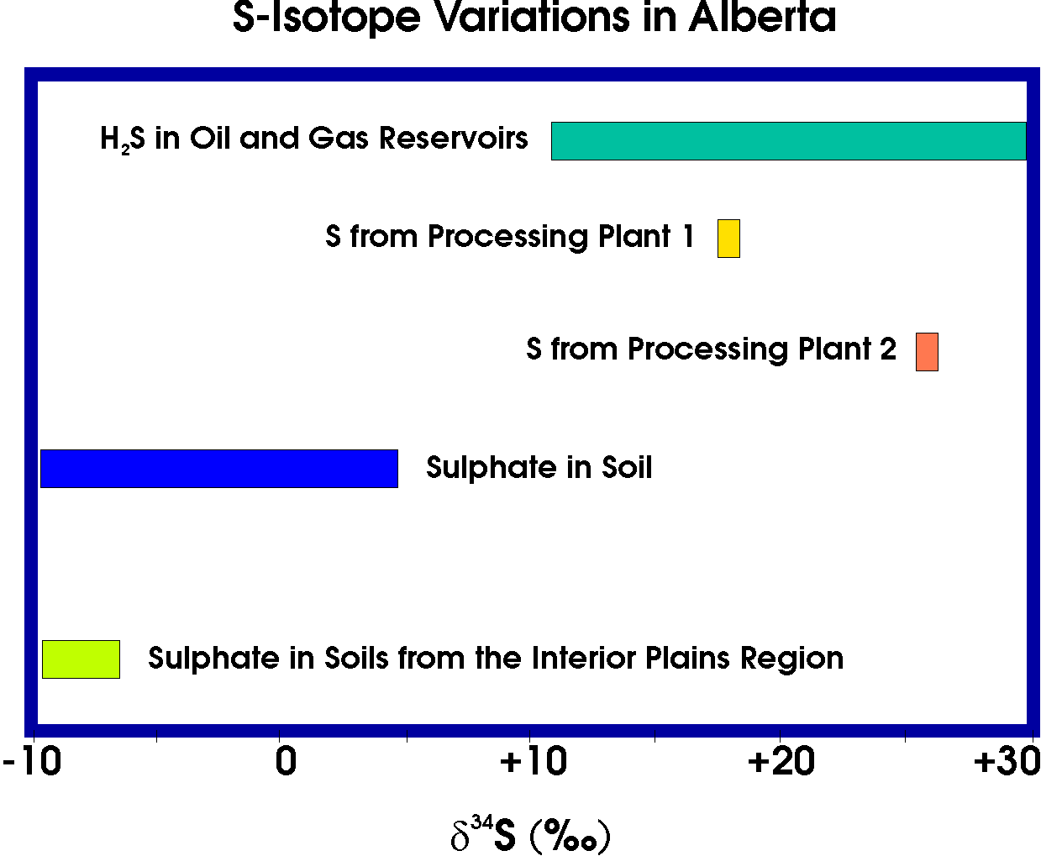

Figure 1. The isotope composition of sulphur sources in Alberta.

In contrast to the ³⁴S-rich sulphur associated with H₂S in oil and gas reservoirs, sulphur in soils throughout Alberta is isotopically light, ranging from –30 to +5 ‰ (Pankina, 1991; Krouse and Case, 1981; Lowe et al., 1971). Again, at a specific site the isotope composition may be quite uniform. For example, sulphate in the tills of the Interior Plains of southeastern Alberta has δ³⁴S values of –9 ± 2 ‰ (Hendry et al., 1989). Sulphur in vegetation typically reflects the isotope composition of sulphate at root depth. However under sulphur stress coniferous trees release H₂S through an isotopically selective process that leaves the needles isotopically heavier than soil sulphate (Krouse, 1977b).

In this study, the isotope composition of soils, vegetation, elemental sulphur and sulphur emissions from sour gas processing and extraction facilities were examined to assess the potential of using isotope tracing techniques in the eastern British Columbia region.

2. Study Area

Oil and gas production and exploration in British Columbia is largely centered in the northeastern quarter of the province with a large concentration of industrial activity near Fort St. John (Figure 2). Development has taken place in both sweet (<5 % H₂S) and sour (>5 % H₂S) reservoirs. Sour gas from multiple fields is processed primarily by one of three facilities; Fort Nelson Gas Plant at Fort Nelson, Pine River Gas Plant at Chetwynd, and McMahon Gas Plant at Taylor, all owned by Duke Energy, producing a total of about 900,000 tonnes S/yr. A smaller processing plant is also found at Cypress and a fifth is PetroCanada
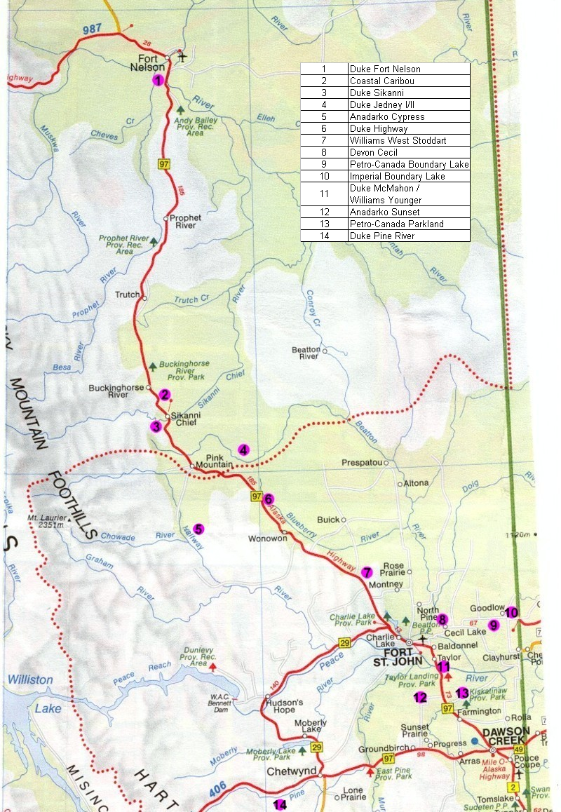
Figure 2. Map of the study area.

Boundary Lake. Flaring activities at several smaller facilities release both SO₂ and sulphate to the environment but at much lower rates than the three processing facilities, and environmental impacts from emissions at smaller facilities are anticipated to be correspondingly lower.
3. Atmospheric Sulphur Emissions

3.1. Characteristics of Sulphur Emissions

Atmospheric sulphur from sour gas processing or flaring can be found in gaseous and/or aerosol form. Sour gas processing facilities typically strip all particulate matter from the flue stack and emit only gaseous products including SO₂. Downwind of the stack, SO₂ may oxidize to form sulphate, or may be deposited to surfaces, typically soil and vegetation. In contrast, flaring activities release both gases and aerosols so sulphate and SO₂ can be found downwind of the stack. Sulphur dioxide formed during combustion is expected to have the same isotope composition as the fuel source, in this case H₂S from the reservoir, and elemental sulphur stripped from the gas stream. Studies to examine sulphur isotope fractionation during the formation of sulphate suggest very little fractionation occurs (Norman et al., 2001; Newman, 1981).

Characterisation of sulphur emissions from the extraction and processing sites shown in Figure 2 was performed by collecting elemental sulphur when available, and atmospheric samples downwind of the stacks. The isotope composition of bulk sulphur stripped from the gas stream is reflected in the δ³⁴S of elemental sulphur. In contrast, atmospheric measurements reflect the isotope composition of material processed at the time of sampling. Data collected by the authors for other studies show that δ³⁴S values for elemental sulphur and SO₂ coincide, and were constant within a few ‰ over 10 years of sampling at a sour gas processing plant in Alberta. However, the isotope composition of emissions may not be as uniform at processing plants where condensate and waste gas is trucked in for processing from other facilities where the δ³⁴S values for H₂S are quite variable.

3.2. Sampling Methodology

Elemental sulphur was collected from the Cypress, Fort Nelson, Pine River, and Enersul Pine River sites on October, 2001 and from Petro-Canada Boundary Lake November, 2001. Additional samples were collected on a separate occasion (April 2002) from the Pine River and Fort Nelson sites. Sampling at different locations and times provides information about the spatial and temporal homogeneity of the feedstock.

Atmospheric sulphur was collected downwind of each site using high and/or low volume sampling techniques. A High Sierra battery operated D.C. high volume sampler was modified to accept a quartz fibre filter to collect particulate matter above a second filter, impregnated with K₂CO₃ and glycerol for the collection SO₂. A similar dual filter technique was used for low volume sampling powered by the vehicle and using a DC to AC inverter. A test of the impact of vehicle exhaust on low volume sampling showed that this was negligible. Sulphur dioxide better represents local emissions than sulphate due to its shorter lifetime (~ days versus weeks). Therefore, only results for sulphur dioxide are presented below.

Plume sampling consisted of locating the plume by sight and smell. Confirmation of the presence of plume gas was verified in several cases using a handheld volatile organic compound (VOC) monitor and from the presence of sulphur in amounts significantly above background levels on the filter paper.

3.3. Results

Table 1 shows the δ³⁴S values for elemental sulphur from each of the facilities where this was available. Elemental sulphur from the Enersul facility, which processes sulphur from the Pine River Plant had the same isotope composition as elemental sulphur from the Pine River Block (+11.6 and +12.1 ‰ respectively). No difference was observed for Enersul S sampled 6 months later (+11‰). The uniformity of the elemental S samples collected so far suggests the influence due to varying isotope composition of the feedstock is small. Samples collected on two dates from the Fort Nelson Plant also agreed; +15.8 ‰ in October, 2001 versus +16 ‰ in May, 2002. Elemental S from the Cypress and Boundary Lake facilities had similar δ³⁴S values, +12.4 ‰, and +15.2 ‰ respectively. In each case, the isotope composition of extracted sulphur is within the range expected for H₂S from deep oil and gas reservoirs.

Table 1. δ³⁴S Values for elemental sulphur.

Plant Name | Sample Date | δ³⁴S (‰)
Duke Fort Nelson | 28-Oct-01 | +15.8 ± 0.1
Duke Fort Nelson | May-02 | +16
Anadarko Cypress | 28-Oct-01 | +12.4 ± 0.7
Petro-Canada Boundary Lake | 17-Nov-01 | +15.2 ± 0.4
Duke Pine River | 29-Oct-01 | +11.6 ± 1.1
Enersul Pine River | 29-Oct-01 | +12.1 ± 0.1
Enersul Pine River | May-02 | +11

Sulphur dioxide was collected at Cypress on two occasions. Both high and low volume samplers were used and similar δ³⁴S values were found for SO₂ and elemental sulphur (Table 2). However, δ³⁴S are lighter than elemental S in each case. Plume sampling downwind of a stack at ground level may incorporate varying proportions of sulphur from background sources. At Pine River, background sulphur was found to be isotopically light (~ -3 ‰). Incorporation of varying proportions of background and emission S are expected to give intermediate δ³⁴S values for SO₂. Samples containing a greater proportion of emission S have δ³⁴S values closer to that for elemental S. Hence, the results for SO₂ reported here do not directly reflect the isotope composition of stack emissions which may be more positive.

Table 2. δ³⁴S values for ambient SO_{2.}

Plant Name | Sample Date | Sample Method  (high or low volume) | δ³⁴S
Duke Fort Nelson | 28-Oct-01 | - | +8.4 ± 0.5
Coastal Caribou | 27-Oct-01 | L | -
Duke Sikanni | 28-Oct-01 | L | +6.8 ± 2
Duke Jedney I/II | 27-Oct-01 | L | +10.0 ± 2
Anadarko Cypress | 28-Oct-01 | L | +10.1 ± 2
Anadarko Cypress | 22-May-02 | L | +4.7 ± 0.5
Anadarko Cypress | 22-May-02 | H | +9.2 ± 0.5
Duke Highway | 27-Oct-01 | L | +11.9 ± 0.5
Williams West Stoddart | 26-Oct-01 | L | +2.4 ± 0.5
Williams West Stoddart | 22-May-02 | L | -
Williams West Stoddart | 22-May-02 | H | +2.4 ± 0.5
Devon Cecil | 17-Nov-01 | L | +12.1 ± 0.5
Petro-Canada Boundary Lake | 17-Nov-01 | L | +11.6 ± 0.5
Imperial Boundary Lake | 17-Nov-01 | L | +11.6 ± 2
Duke McMahon | 26-Oct-01 | L | +11.4 ± 2
Duke McMahon /  Williams Younger | 26-Oct-01 | L | +6.3 ± 2
Anadarko Sunset | 18-Nov-01 | L | +11.3 ± 0.5
Petro-Canada Parkland | 18-Nov-01 | L | +11.3 ± 0.5
Duke Pine River | 18-Nov-01 | H | +4.8 ± 0.5
Duke Pine River | 23-May-02 | L | +8.4 ± 2
Duke Pine River | 23-May-02 | H | +4.4 ± 0.5

Isotopically light sulphur dioxide as compared to elemental S was also observed at Pine River, Fort Nelson, and Petro-Canada Boundary Lake. On average, δ³⁴S values for sulphur dioxide were 5 ‰ lighter than those for elemental S. Isotope and chemical data described in the following section on vegetation suggests coniferous trees at sites approximately 1 to 2 km downwind from the Pine River plant produced isotopically lighter H₂S as a result of sulphur stress (Krouse, 1977b). If this effect is pervasive in the vicinity of the processing plants, it may have introduced a sampling artifact in the ambient SO₂ samples. Stack emissions typically reach ground level 10 stack heights from the source. However, sampling was performed close to the processing plants at Pine River, Cypress, and Fort Nelson due to difficulties in accessing the plumes from downwind. If vegetation H₂S, which is isotopically light sulphur, influences local air quality, then the δ³⁴S of SO₂ which was collected within a few hundred meters of the stack may reflect a mixture of SO₂ from the plume and vegetation emissions. For future studies, either stack sampling, or airborne plume sampling will be conducted for SO₂ emissions at the sampling site. Air samples at other sites with much lower emission (and deposition) rates may have been less affected by emissions from stressed vegetation.

The isotope composition of SO₂ at other sites was quite variable. Emissions from the West Stoddart plant were consistently the lightest isotopically by far, at +2.4 ‰ on two occasions. SO₂ downwind of the Sikanni plant was found to have a composition of +6.8 ‰, while the remainder of the plants had SO₂ that ranged from +9.2 to +12.1 ‰ (see Table 2). In some cases, samples taken at the same location at the same time using two different sampling methods yielded significantly different isotopic values. However, in each case the low volume apparatus was moved well away from the high volume sampler so as not to introduce any vehicle contamination, and therefore the low volume sample was not directly downwind of the plant and background contribution was significantly higher. The same effect was observed for two samples taken at the Duke McMahon Plant and the Williams Younger Plant, which process the same gas and are located adjacent to one another. Sampling at a location directly downwind of the McMahon facility gave an isotopic composition of +11.4 ‰, while sampling downwind of both plants gave +6.3 ‰, indicating increased background contribution. In some cases, sampling using the low volume technique did not yield enough SO₂ to provide an analyzable sample, as was evidenced by the data for the Caribou plant and for one West Stoddart sample. With the exception of West Stoddardt, the isotope composition of sulphur in emissions from gas processing facilities is in the same range as plants in Alberta, above +10 ‰.

4. Isotope Characteristics of Vegetation and Soils

4.1. Methodology

Pine needle material and soil samples were collected in May 2002 from eight different sites [note that 4/5; 6/7; 8/9 are counted as one site respectively because they are very close to each other] in the study area (Figure 3). At each site, between 3 and 5 trees were selected, from which pine needles were obtained using a pole pruner. At the same or a nearby location, soil samples were obtained. Where possible, litter, A-, B-, and C- horizons were sampled individually.

Samples were returned to the laboratory and dried at 40ºC. Pine needle material was age classed (4 needle years per tree) and finely ground (40 mesh). Soils samples were sieved (2 mm) and homogenized. Subsequently, total sulfur was extracted from pine needles using the Parr bomb technique and from soil samples via nitric acid bromide oxidation (Krouse et al., 1996). Total S was converted to BaSO₄, which was subsequently converted to SO₂ for isotope ratio determinations. Results are expressed in the usual delta notation as defined above.

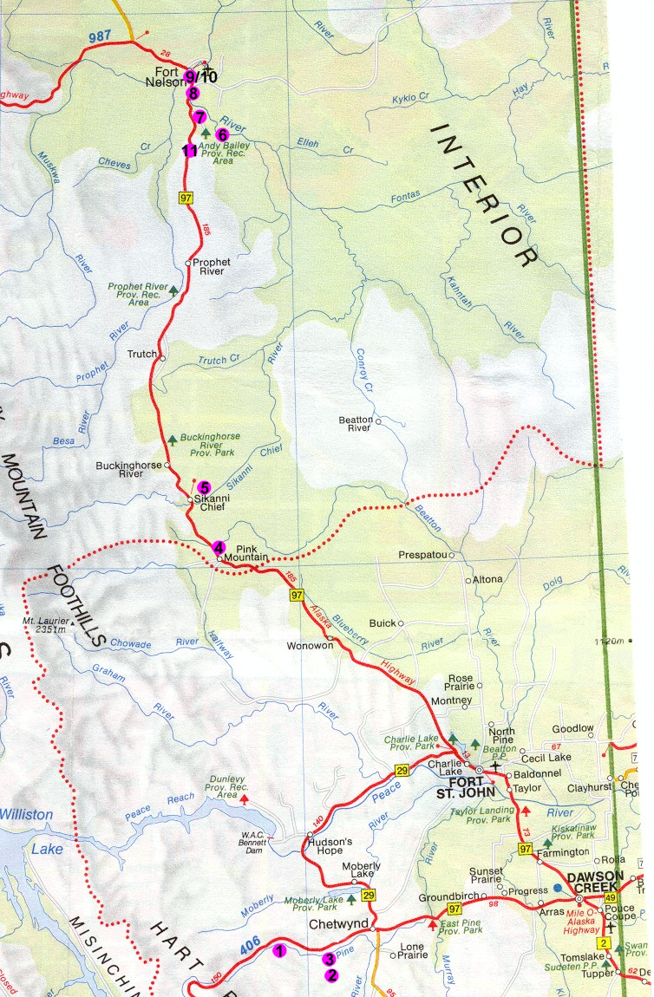

Figure 3. Map identifiying the location of vegetation and soil sampling.

4.2. Results

δ³⁴S values for total sulfur in pine needles in the vicinity of the Pine River Gas plant (PRGP) and the Fort Nelson Gas Plan (FNGP) are shown in Tables 3 and 4. Within a given site δ³⁴S analyses on pine needles of different age classes and of pine needles from different trees were typically almost identical (std.dev. typically ± 1.0 ‰). Hence, the following discussion will be based on average values for the respective sites.

Table 3. δ³⁴S values of total sulfur in pine needles and soils from the vicinity of the Pine River Gas plant (PRGP).

 | Site 1 | Site 2 | Site 3 | Site 4/5
Site location | Valley west of PRGP | Hill B south of PRGP | 1-2 km down-wind of PRGP | Mae’s Kitchen
Tree 1 | -7.1 | +4.9 | - | +1.7
Tree 2 | +4.9 | +7.1 | - | +1.2
Tree 3 | +4.2 | +5.0 | +14.4 | +0.1
Tree 4 | +3.3 | +5.4 | +14.4 | -
Tree 5 | +5.7 | +6.3 | +12.5 | -
Litter | - | +6.3 | - | -
A-horizon | +4.4 | +5.5 | +9.8 | -2.1
B-horizon | +3.7 | +4.3 | +9.4 | -5.2
C-h./bedrock | -8.7 | Not sampled | Not sampled | -16.5

δ³⁴S values of total sulfur in pine needles at background sites in the larger vicinity of the Pine River plant varied between +4.5 ‰ (site 1) and +1.0 ‰ (site 4). δ³⁴S values of pine needles obtained from hill B south of the gas plant (site 2) were on average +5.7 ‰, indicating at most a minor influence of industrial S from the Pine River gas plant. Total sulfur in pine needles from the site 2 km downwind of the gas plant (site 3) showed the highest δ³⁴S values, on average +13.8 ‰. This value is almost 3 ‰ higher than that of the industrial S emissions from the Pine River gas plant. This indicates a high level of industrial S in the pine trees from this site. Additionally, higher δ³⁴S in the pine needles as compared to industrial emissions seem to suggest that these trees release isotopically light H₂S, leaving the remaining plant S enriched in ³⁴S.

Soil S in the A horizons where plants typically receive their nutrients is isotopically very similar to sulphur in the needles. An exception is seen for site 3, where S stress may have caused an increase in needle δ³⁴S.

Table 4. δ³⁴S values of total sulfur in pine needles and soils from the vicinity of the Fort Nelson Gas plant (FNGP).

 | Site 10 | Site 8/9 | Site 6/7 | Site 11
Site location | 1 km north of FNGP | 5 km NE of FNGP | Near Andy Bailey | 50 km south of FNGP
Tree 1 | +9.5 | -5.0 | +7.2 | -4.4
Tree 2 | +8.5 | -4.9 | +5.8 | -2.4
Tree 3 | +10.0 | -7.8 | +4.8 | -3.6
Tree 4 | +9.2 | - | - | -5.4
Tree 5 | +6.8 | - | - | -3.6
Litter | - | - | - | -
A-horizon | +7.5 | -1.6 | +2.2 | +0.1
B-horizon | +4.2 | -3.1 | +0.9 | -4.0
C-h./bedrock | - | -18.8 | -8.6 | -

In the larger vicinity of the Fort Nelson gas plant, δ³⁴S values of total sulfur appeared to be around –3.9 ‰ (site 11). Trees sampled at a site northeast of the gas plant (site 8/9) showed even lower δ³⁴S values, indicating no significant influence from industrial S. In contrast, pine trees located approximately 1km north of the gas plant had an average δ³⁴S value of +8.8 ‰ (site 10). These elevated sulfur isotope ratios suggest that a significant proportion of the plant S on this site is derived from industrial emissions. δ³⁴S values of total S from pine trees near Andy Bailey (site 6/7) also had elevated δ³⁴S values (+6.0 ‰), presumably indicating the presence of industrial S.

Soil S data from the A horizon is isotopically similar to that for the needles at site 10, where the impact of industrial S is suspected. It is also ³⁴S-rich with respect to the remaining sites and has a lighter isotope composition at depth. These trends, evident near Pine River as well, probably reflect an increasing contribution from the weathering of bedrock which had light δ³⁴S values; on average –13.1 ± 5 ‰.

Conclusions

Both sites can be used for distinguishing industrial from naturally occurring S. The isotopic leverage is somewhat better at Fort Nelson as compared to Pine River. However additional logistical support at Pine River, may prove this the more attractive site. More work is required to better define background δ³⁴S values and its variability. However, the large differences in δ³⁴S values for sulphur in emissions and non-impacted ecosystems suggests isotopes are an ideal tool for tracking the current and cumulative impacts from gas extraction and processing emissions.

References

Hendry, M.J., Krouse, H.R. and Shakur, M.A. (1989) Interpretation of oxygen and sulphur isotopes from dissolved sulphates in tills of southern Alberta, Canada. Water Resources Research 25, 567-572.

Krouse, H.R., and Mayer, B. (2000). Sulphur and oxygen isotopes in sulphate, Chap. 7 in Environmental Tracers in Subsurface Hydrology. P. Cook and A. Herczeg. Kluwer, Rotterdam, 195-230.

Krouse, H.R., Viau, C.A., Eliuk, L.S., Ueda, A., and Halas, S. (1988) Chemical and isotopic evidence for thermochemical sulphate reduction by light hydrocarbon gases in deep carbonate reservoirs. Nature 333 (6172), 415-419.

Krouse, H.R., and Case, J.W. (1981) Sulphur isotope ratios in water, air, soil, and vegetation near Teepee Creek Gas Plant. Water, Air, Soil Pollut. 15, 11-28.

Krouse, H.R. (1977a) Sulphur isotope studies and their role in petroleum exploration. J. Geochem. Explor., 7, 189-211

Krouse, H.R. (1977b) Sulphur isotope abundances elucidate uptake of atmospheric sulphur emissions by vegetation. Nature 265. 45-46.

Krouse, H.R. (1991) Sulphur isotope tracing of the fate of emissions from sour gas processing in Alberta. In: Stable Isotopes: Natural and Anthropogenic Sulphur in the Environment SCOPE 43 (H.R. Krouse and V.A. Grinenko (eds.), 309 -326.

Lowe, L.E., Sasaki, A., and Krouse, H.R. (1971) Variation in 34S/32S in soil fractions in western Canada. Can. J. Soil Sci. 51, 129 -131.

Newman, L. (1981) Atmospheric oxidation of sulphur dioxide: a review as viewed from power plant and smelter plume studies. Atmos. Environ. 15, 2231-2291.

Norman, A.L., Barrie, L.A., and Belzer, W. (2002) Atmospheric sulphur in the Fraser Valley: A source apportionment study. Report to Northwest and Pacific Region, Meteorological Service of Canada, Environment Canada. January, 2002, 20 pages.

Pankina, R.G. (1991) Lithospheric sources of sulphur: Oil. In: Stable Isotopes: Natural and Anthropogenic Sulphur in the Environment SCOPE 43 (H.R. Krouse and V.A. Grinenko (eds.), 100 -108.

